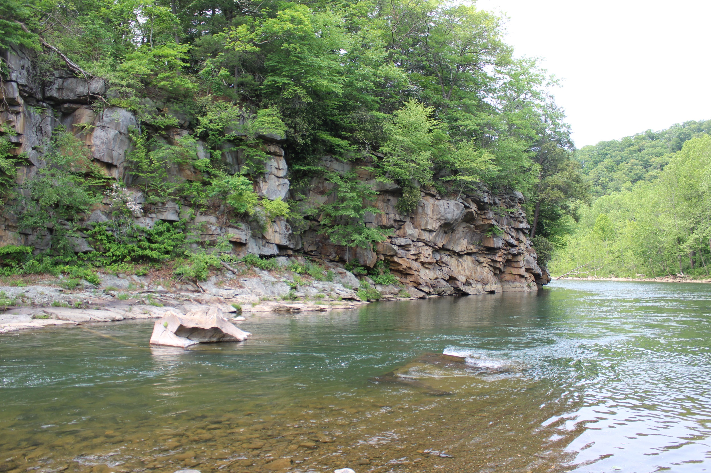

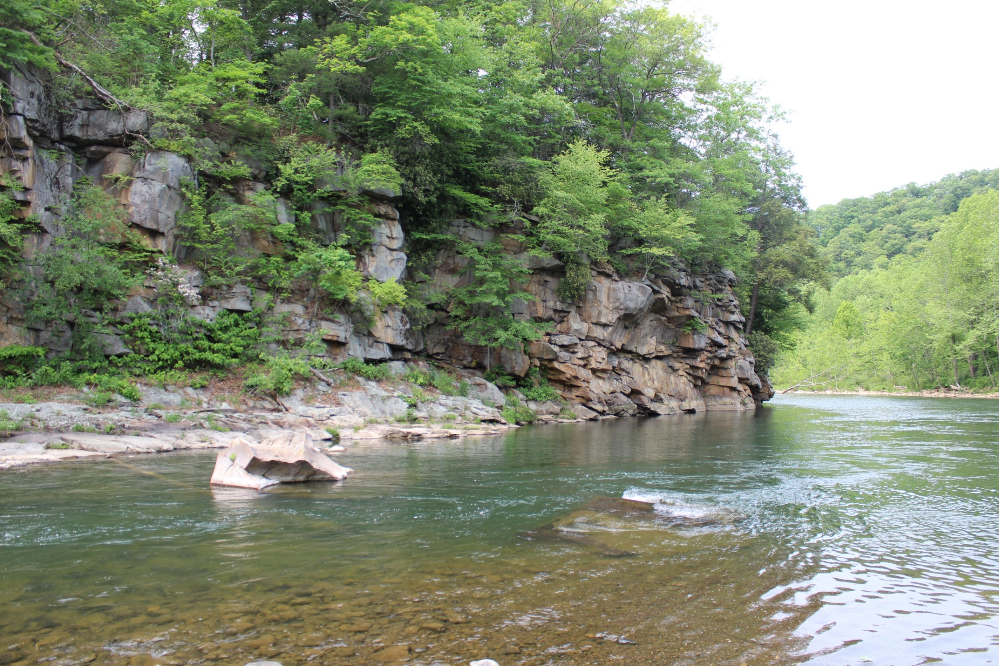

Go Visit Mineral County
West Virginia

Go to a place few have discovered.
Enjoy the beauty in peace.

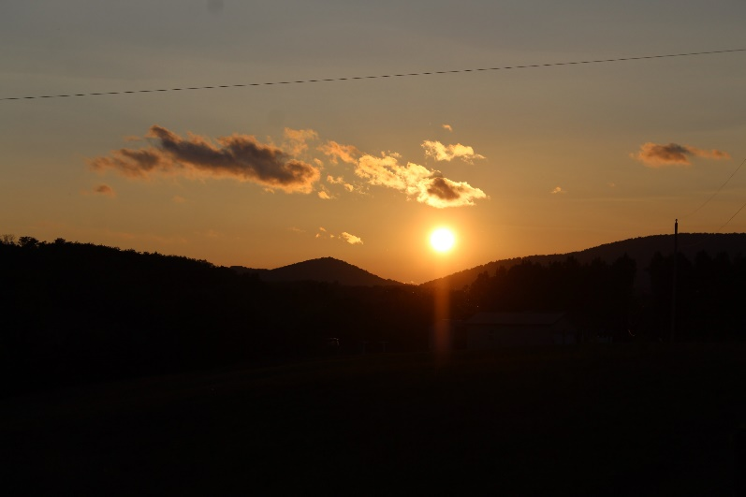
Mineral County is located in the western portion of the eastern panhandle of West Virginia in a region known as the Potomac Highlands. The county is bordered by the North Branch of the Potomac River along the North, separating West Virginia from Maryland. The geologic setting and landscape history make the Potomac Highlands
one of the most scenic areas within the central Appalachian Mountains.

Mineral County has many types of attractions including Jennings Randolph Lake (approximately 6.6 miles long with a surface area of 915 acres) with a beach area, boat launch, camping, and an activity almost every weekend during the warmer months; outdoor recreation areas; golf courses; several historical locations; local museums; scenic drives; farms to visit; unique shopping experiences; two hotels, cabins (some primitive) and several alternative rental properties; and all types of restaurants including one at the local airport in Wiley Ford. Two local businesses were runners-up in WVLiving Magazine’s 2023 Best of West Virginia: North Branch Brewing Co. (best local watering hole) and Wayne’s Country Fresh Meats (best butcher shop), which is more than just a butcher shop!
Leave the crowds behind with a visit to Mineral County, West Virginia!

Go to a place few have discovered.
Enjoy the beauty in peace

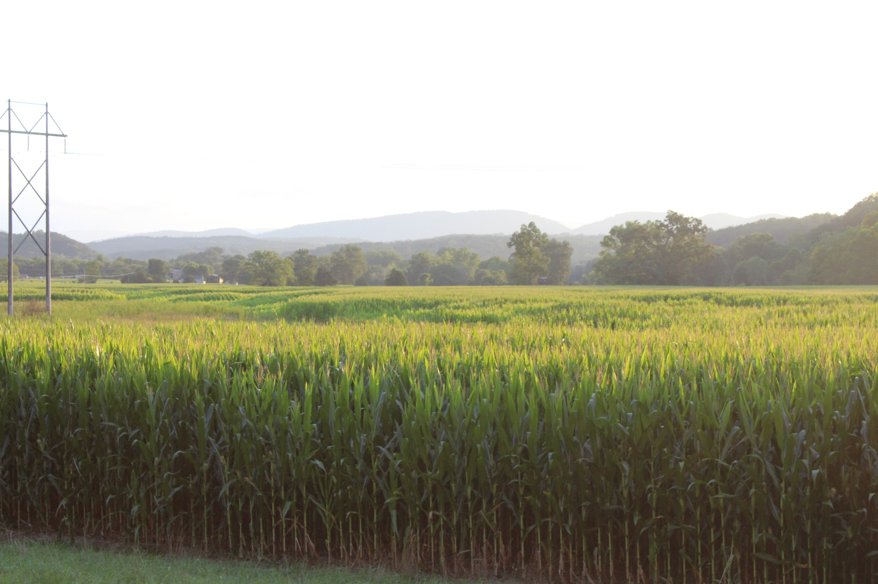

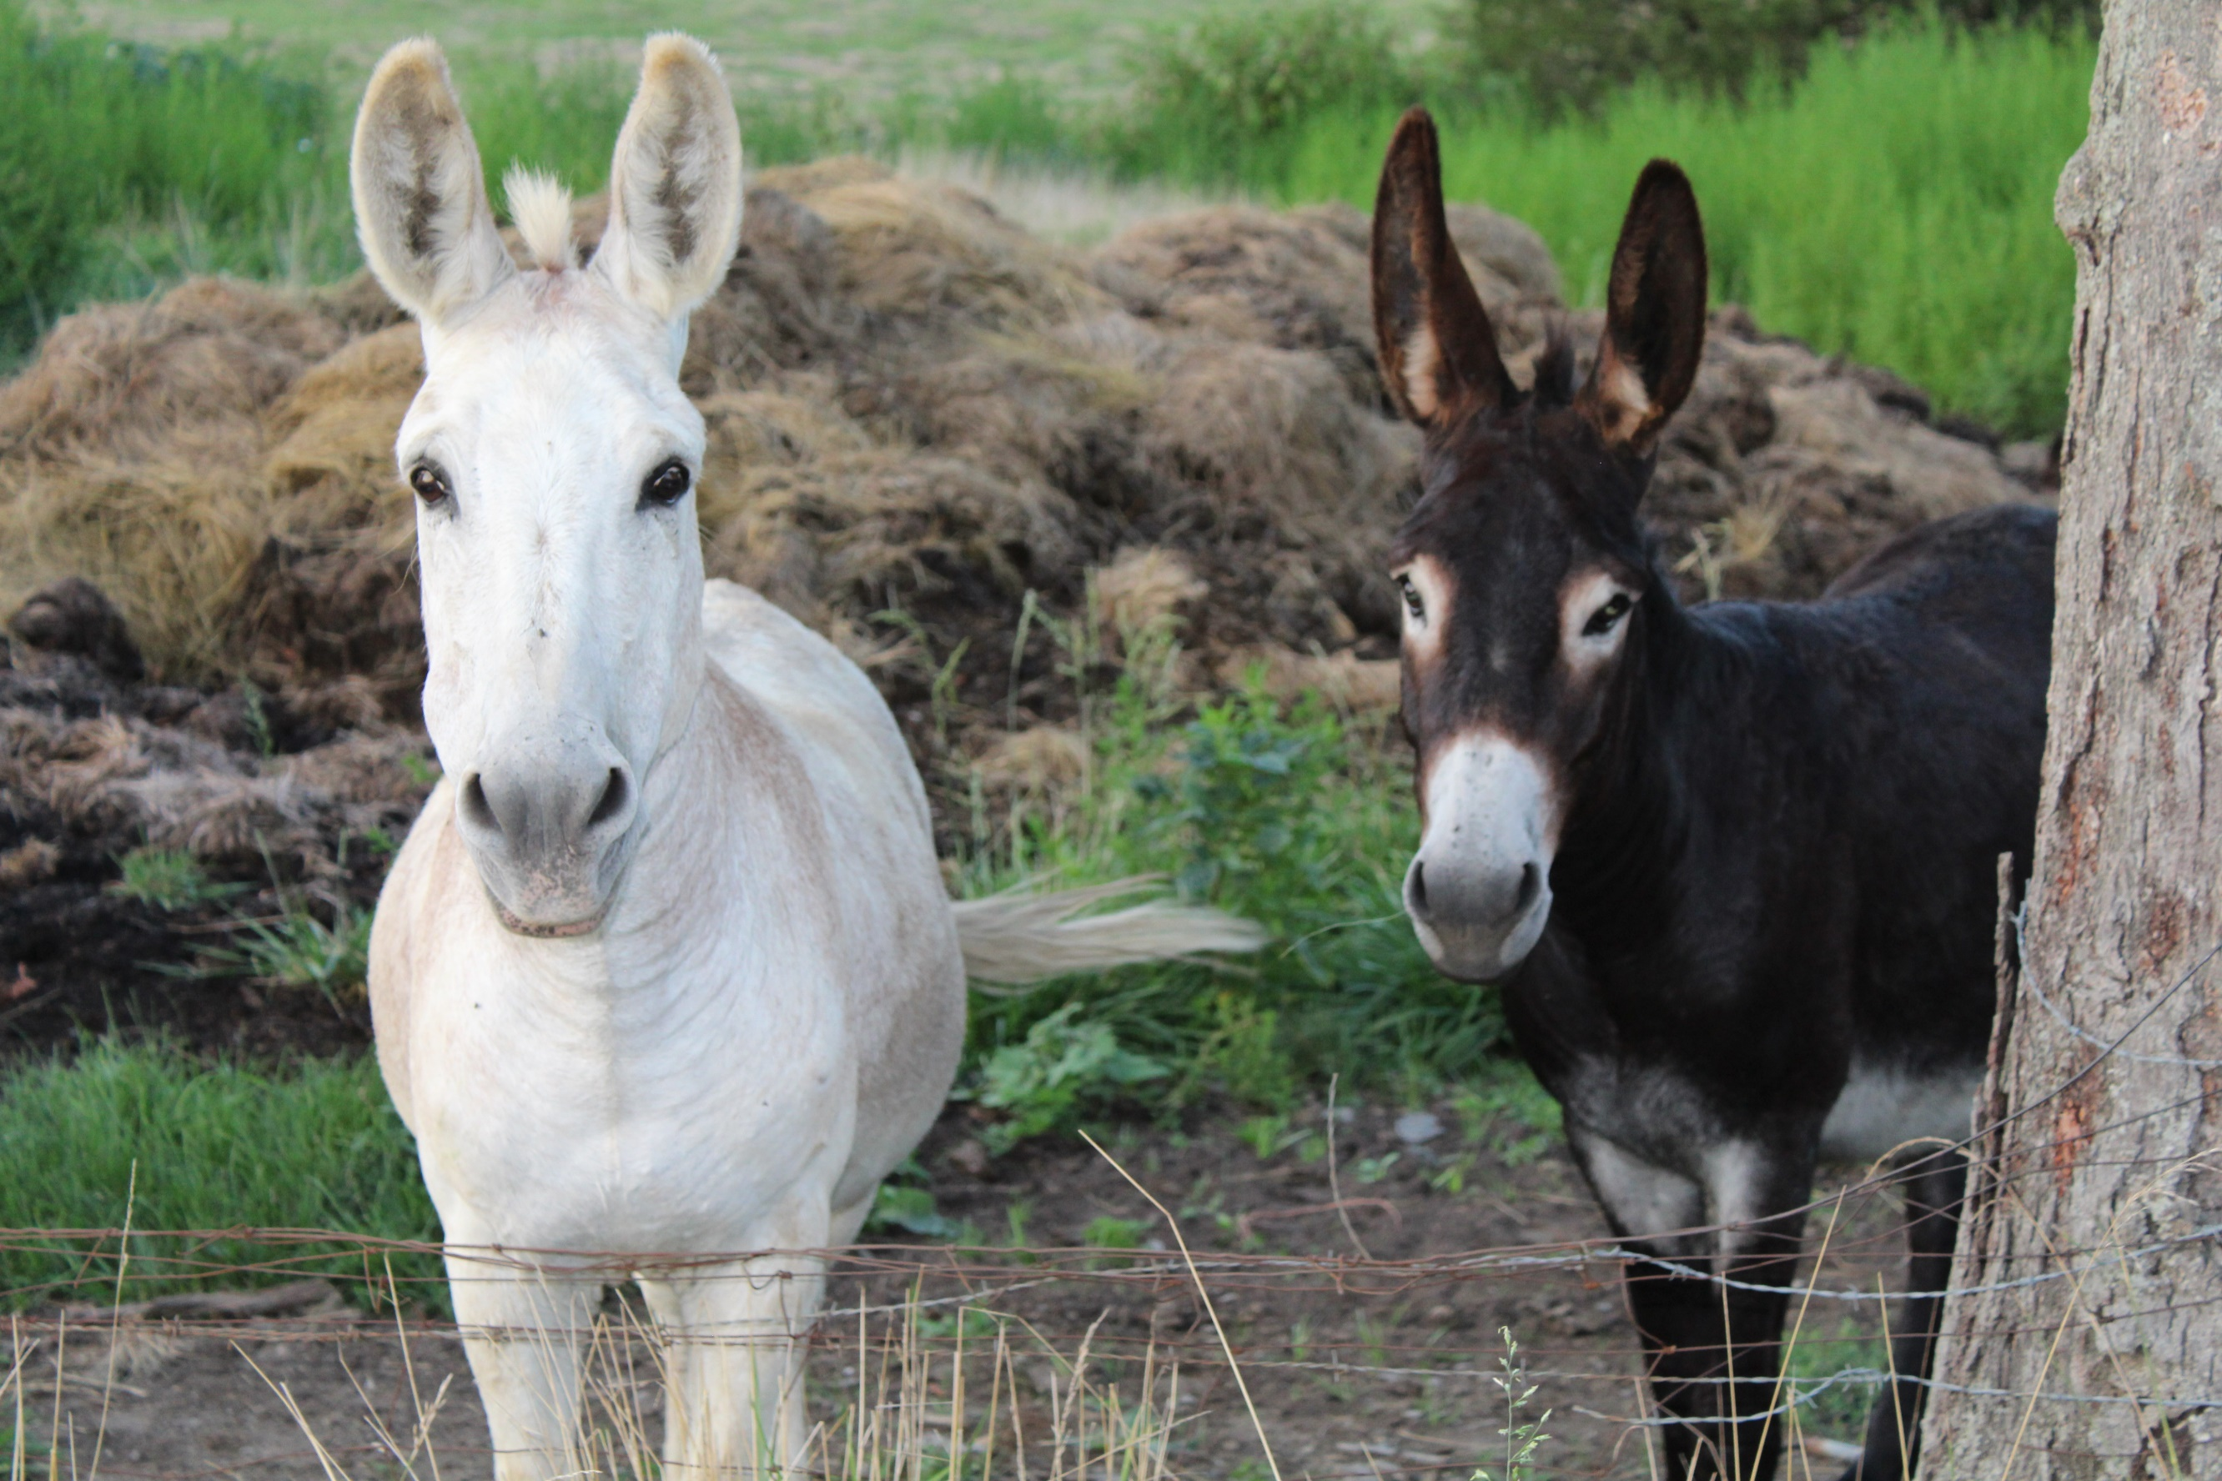
You never know what you might see on a ride through Mineral County!

2024
Mineral County Annual Events

Events Schedule Location

Fort Ashby Concert Season February to December Ashby’s Fort Museum
North Branch
Whitewater Releases April and May Jennings Randolph Lake
Fort Ashby Days First weekend in May Ashby’s Fort Museum
Jennings Randolph Lake
Summer Activities May to October Jennings Randolph Lake
Strawberry Festival First Saturday in June Downtown Keyser
WV Peach Festival First weekend in August Mineral County Fairgrounds
Burlington United Methodist
Apple Harvest Festival First weekend in October Family Services Campus


Notes


Mineral County Tourism Contact Information

Welcome Center: 167 S Mineral Street, Keyser, WV 26726
Phone Number: (304) 790-7081
Website: GoVisitMineralWV.com
Facebook: Mineral County Tourism
Mineral County Places to Stay
Keyser Inn
Make yourself at home in one of the 44 air-conditioned rooms featuring refrigerators and microwaves. Flat-screen televisions with cable programming provide entertainment, while complimentary wireless internet access keeps you connected. Private bathrooms have deep soaking bathtubs and complimentary toiletries. Complimentary continental breakfast is included.
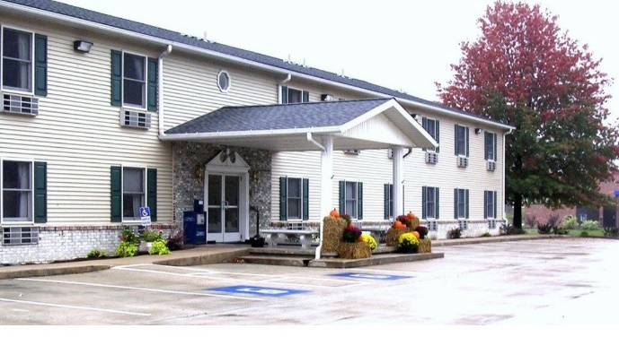

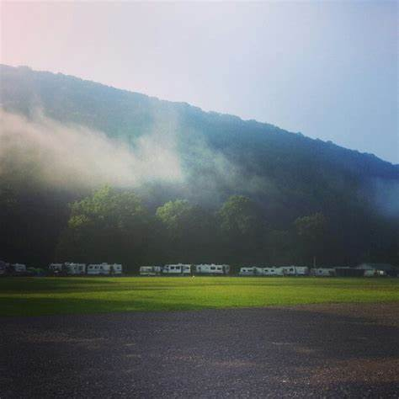
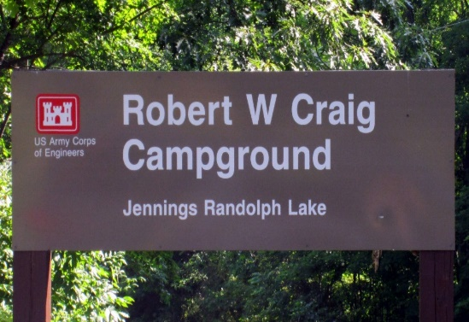


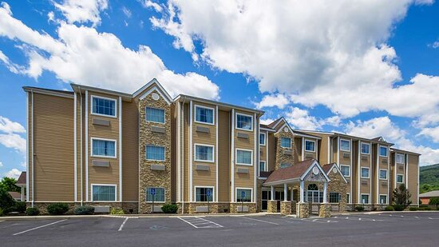
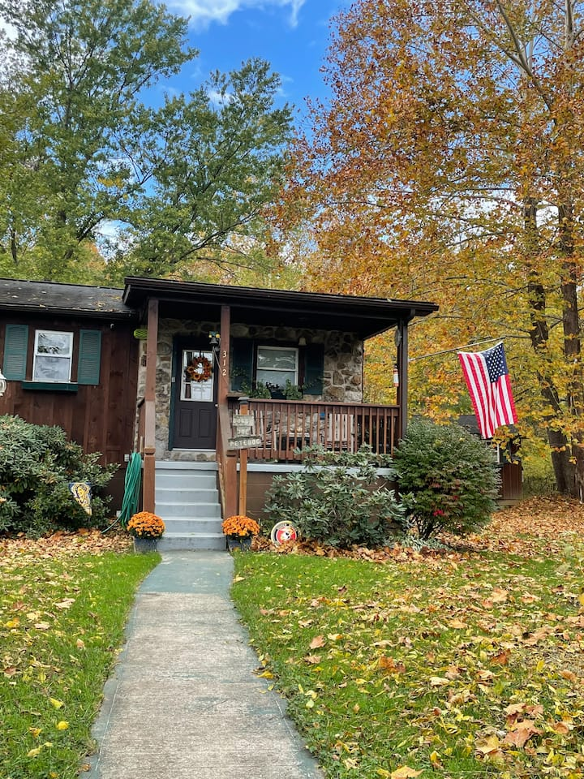
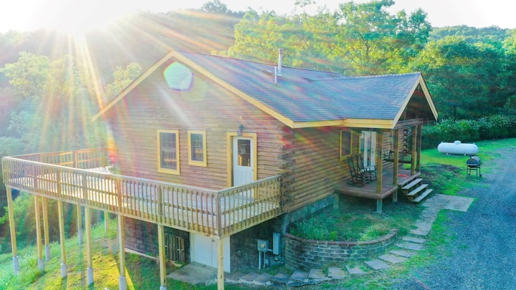
SureStay Plus Hotel
Relax in one of the 61 rooms at SureStay Hotel by Best Western which offers comforts such as laptop-friendly workspaces, air conditioning, hypo-allergenic bedding, pillowtop mattresses, sofa beds, deep soaking tubs, flat-screen televisions with premium channels as well as wardrobes/closets, refrigerators, and microwaves. Stay connected with free in-room WIFI. Other amenities include a business center, meeting room, barbeque grills, complimentary self-serve breakfast, laundry facilities, and a gym.

Robert W. Craig Campground is a family-oriented campground spaciously located on the hills above the Jennings Randolph Lake. The campground has 68 campsites, all of which have electrical services. The facility has hot showers, water hydrants every third or fourth site, and flush toilets at the washhouse and in the back loop comfort station. The campground also features a playground, campground store, horseshoe pits, and a pavilion for evening programs presented by the ranger staff on Saturday nights.
Eagle’s Nest Campground in Ridgeley is a family-friendly, waterfront campground. There is fishing and swimming in Patterson Creek, as well as other amenities, including a playground, pavilion, horseshoe pits, corn hole, volleyball, and basketball. There is an on-site restaurant, Steers & Stripes Saloon, and a place to purchase camping needs. The campground provides fully furnished cabins and tent sites.
Some alternative stays include a cabin in Keyser, an apartment in Ridgeley, and a cabin in Fort Ashby.
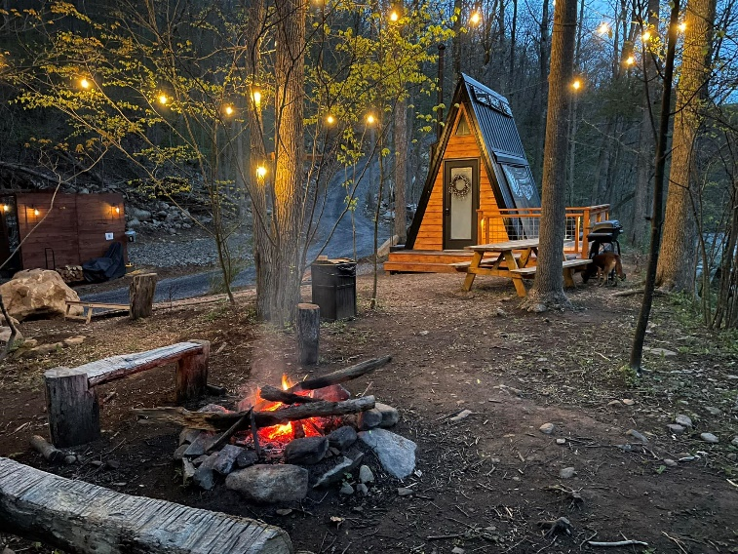
The Wildflower on Abrams Creek

Reconnect with nature with a night away in a tiny home. This lovely A-frame is nestled within 20 secluded acres, powered by solar energy, and including a wood-fired stove. Unwind in the queen size bed while listening to the soothing sounds of the rolling Abrams Creek nearby. Spend your evenings playing corn hole, cooking dinner on the grill, or enjoying quality time by the campfire.
https://TheWildflowerWV.com

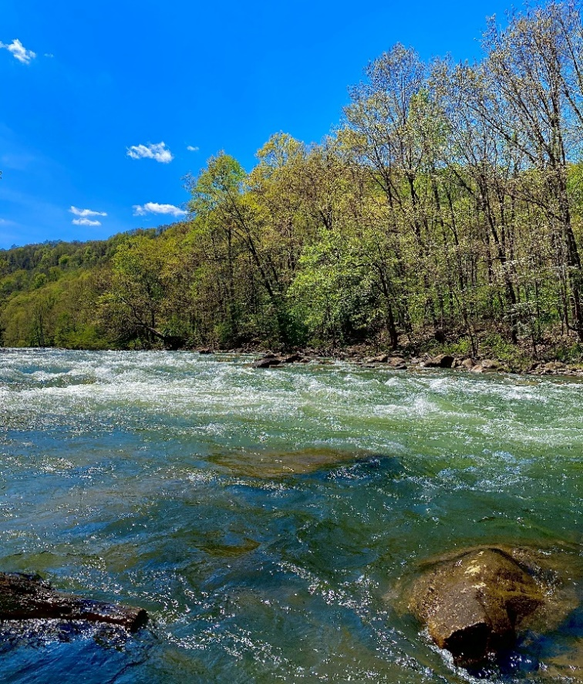
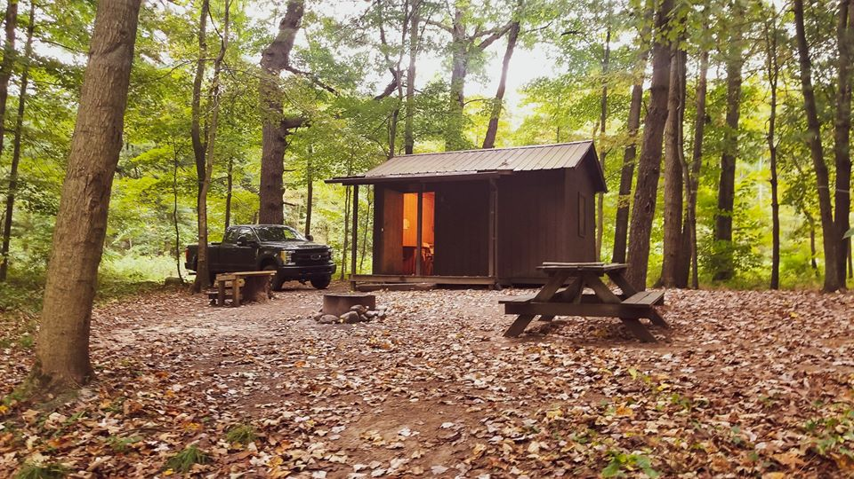
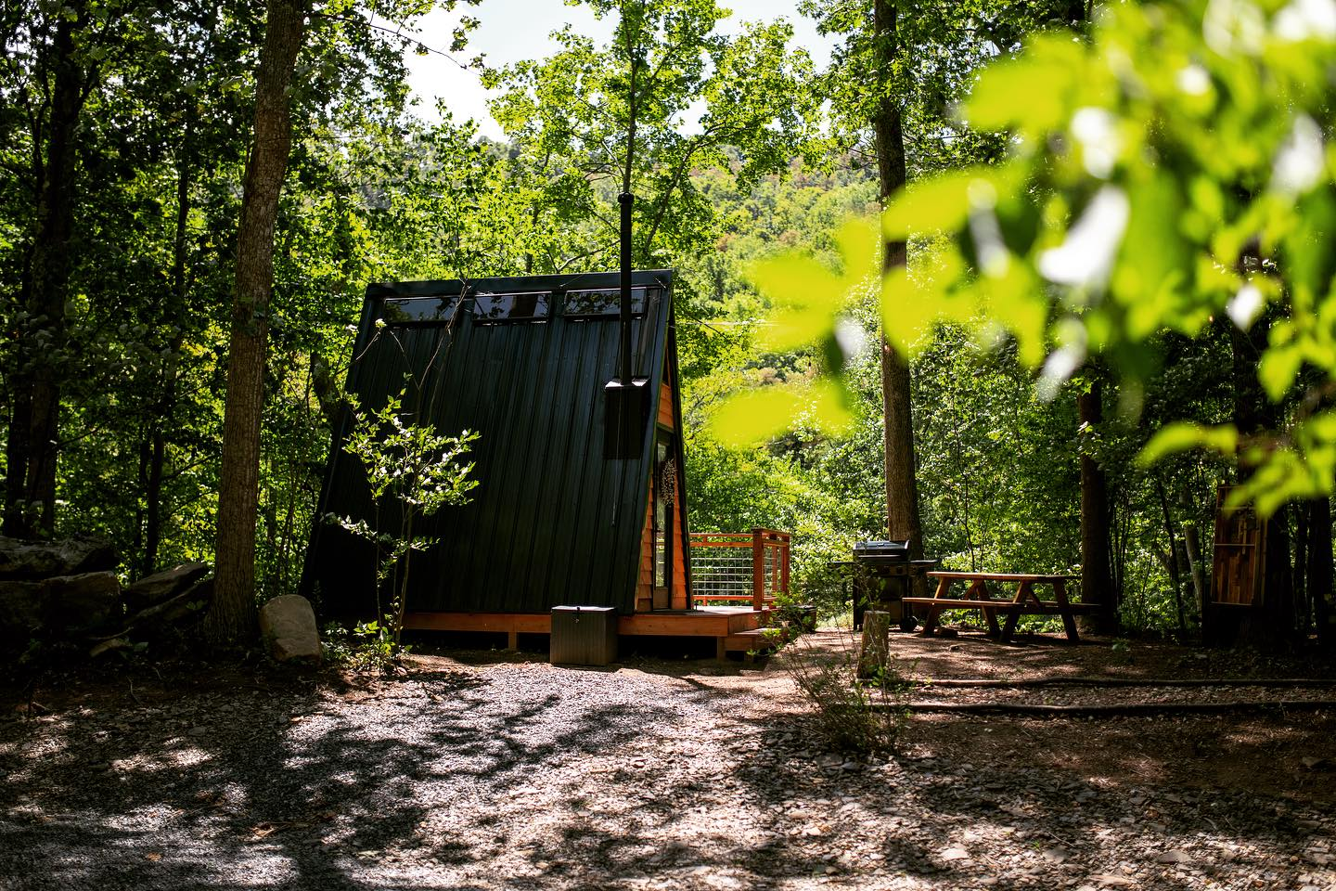
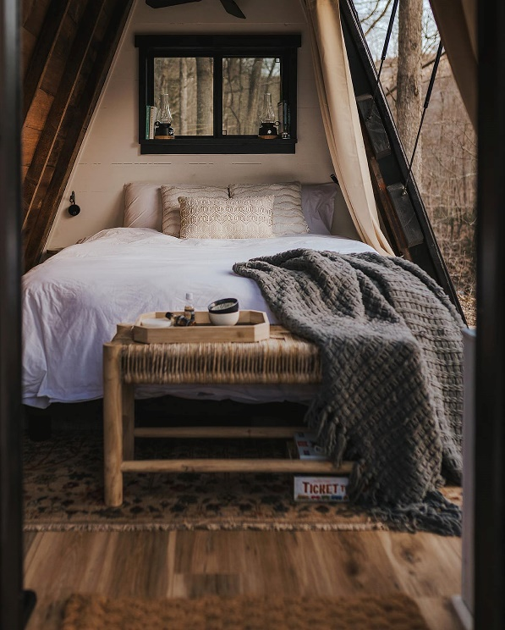
There are nine primitive cabins and one recently converted fancy cabin (hardwood flooring, A/C and heat, furniture, and a mini-fridge) available for rent. There are also nine tent sites (available on a first-come basis). A waterless restroom facility is located in the parking area.
www.BarnumCabins.com

Cabins at Barnum
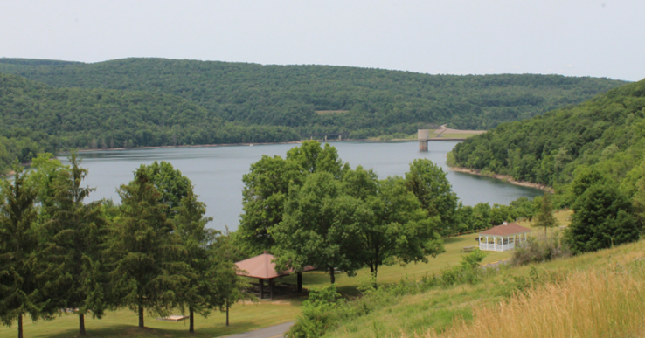
Jennings Randolph Lake

Located in Elk Garden, Jennings Randolph Lake provides a picnic area, beach, trails and boat launch. The picnic area includes three covered pavilions that hold up to 50 guests, picnic tables, grills, restroom facilities, playground, sand volleyball court, horseshoe pits, and more. There are three trails: High Timber Trail (.8 miles), Lakeside Trail (.75 miles), and Sunset Trail (1.8 miles). Shaw Beach is a 200-foot swim beach with a changing station/restroom, wash station, playground equipment, and more. Lifeguards are not present, but safety throwing rings are available. Beach rules and regulations are posted on the bulletin board. Howell Boat Launch is located off Route 46 and consists of a two-lane concrete ramp with a floating dock for temporarily loading and unloading boats. Motorboats, sailboats, and other watercraft frequent the lake, with water skiing and fishing being the most popular. The lake is primarily stocked with trout but also has large/small-mouth bass and walleye.

The overlook provides a panoramic view of the dam, outlet works, and lake. A rare geologic structure known as “Waffle Rock” is showcased at the overlook. It is a portion of the sandstone bedrock that was folded on itself and fractured during the formation of the Appalachian Mountains over 300 million years ago.
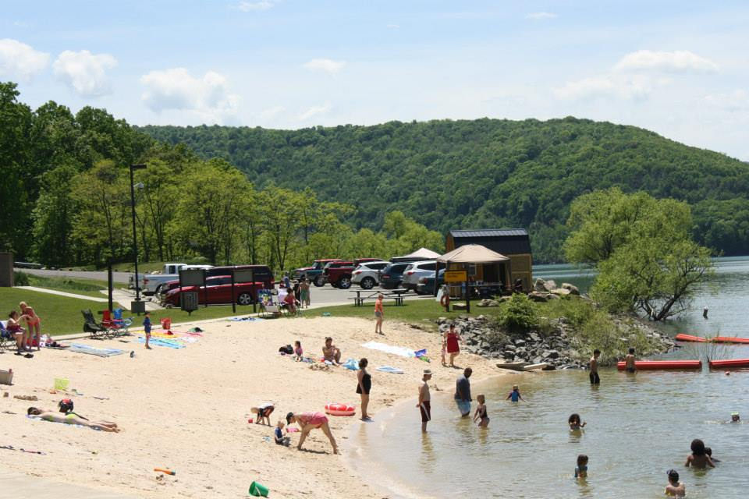
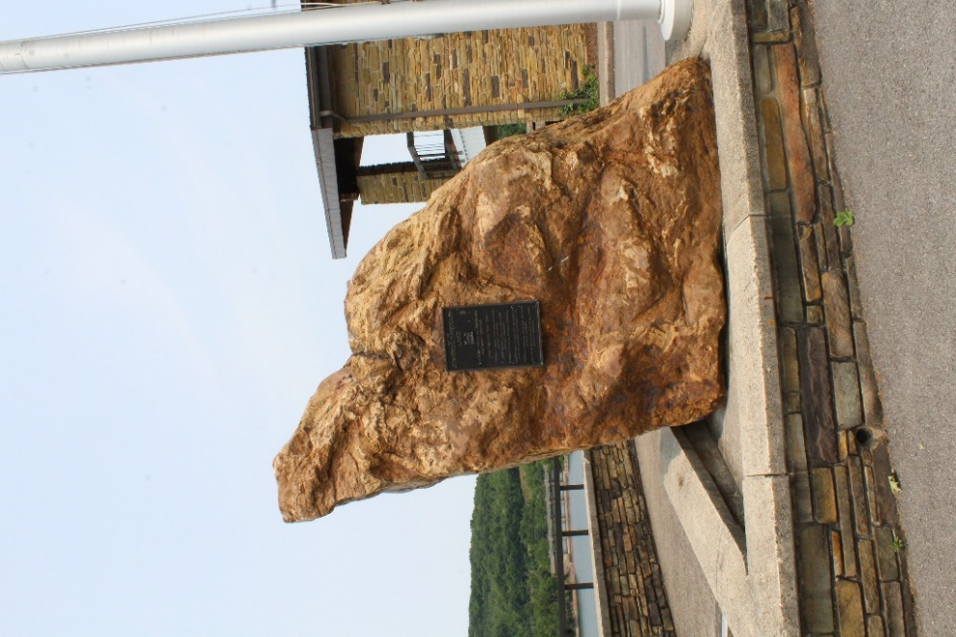
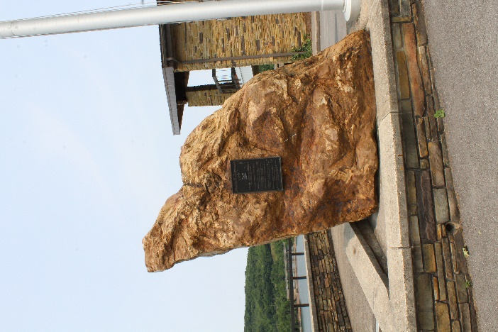
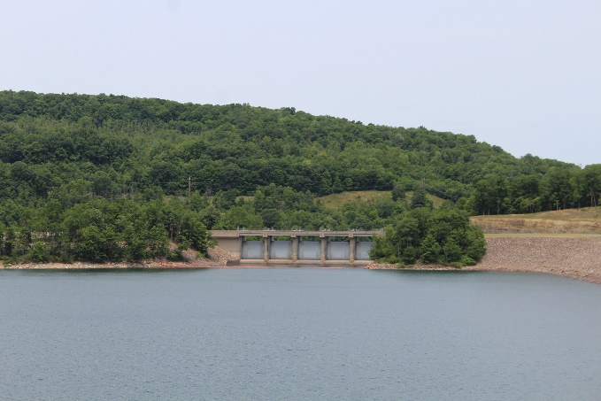
Barnum Whitewater Area


The North Branch of the Potomac is a whitewater rafting river for the entire family. Whitewater releases from Jennings Randolph Lake tumble down a continuous gradient of sandstone ledges and cobbles providing class I, II, and III rapids in close succession, comprised of waves and rollers up to six feet high. Short spells of calm water permit bailing, relaxation and swimming. Trip length is seven miles. The launching area is located in the Barnum Whitewater Area (BWA). Parking and restroom facilities are available at the launch site. The Mineral County Parks & Recreation Commission has instituted a $5.00 per person fee for all individuals entering BWA on release dates. Each release is from 10am - 4pm.

Whitewater releases from Jennings Randolph Lake are scheduled in April and May. The maximum flow is 1500 cubic feet per second (CFS) during a whitewater release.

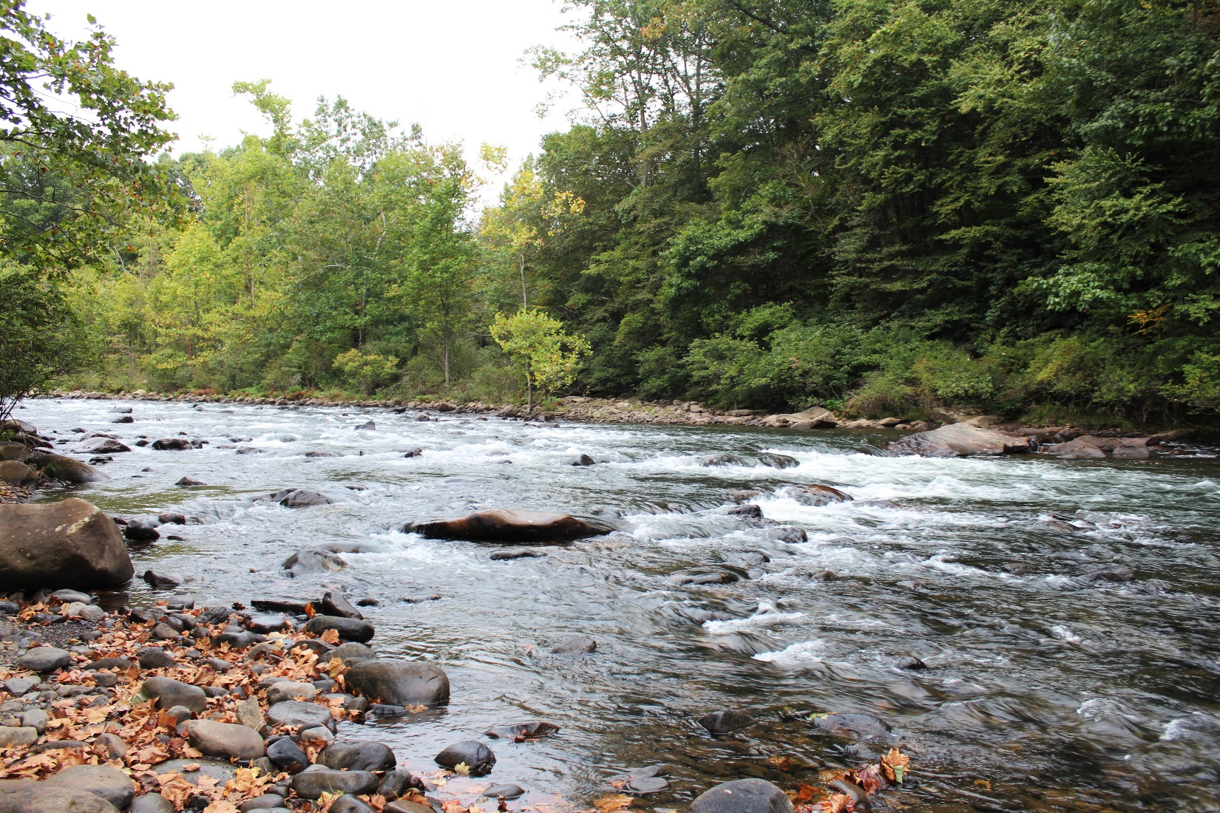
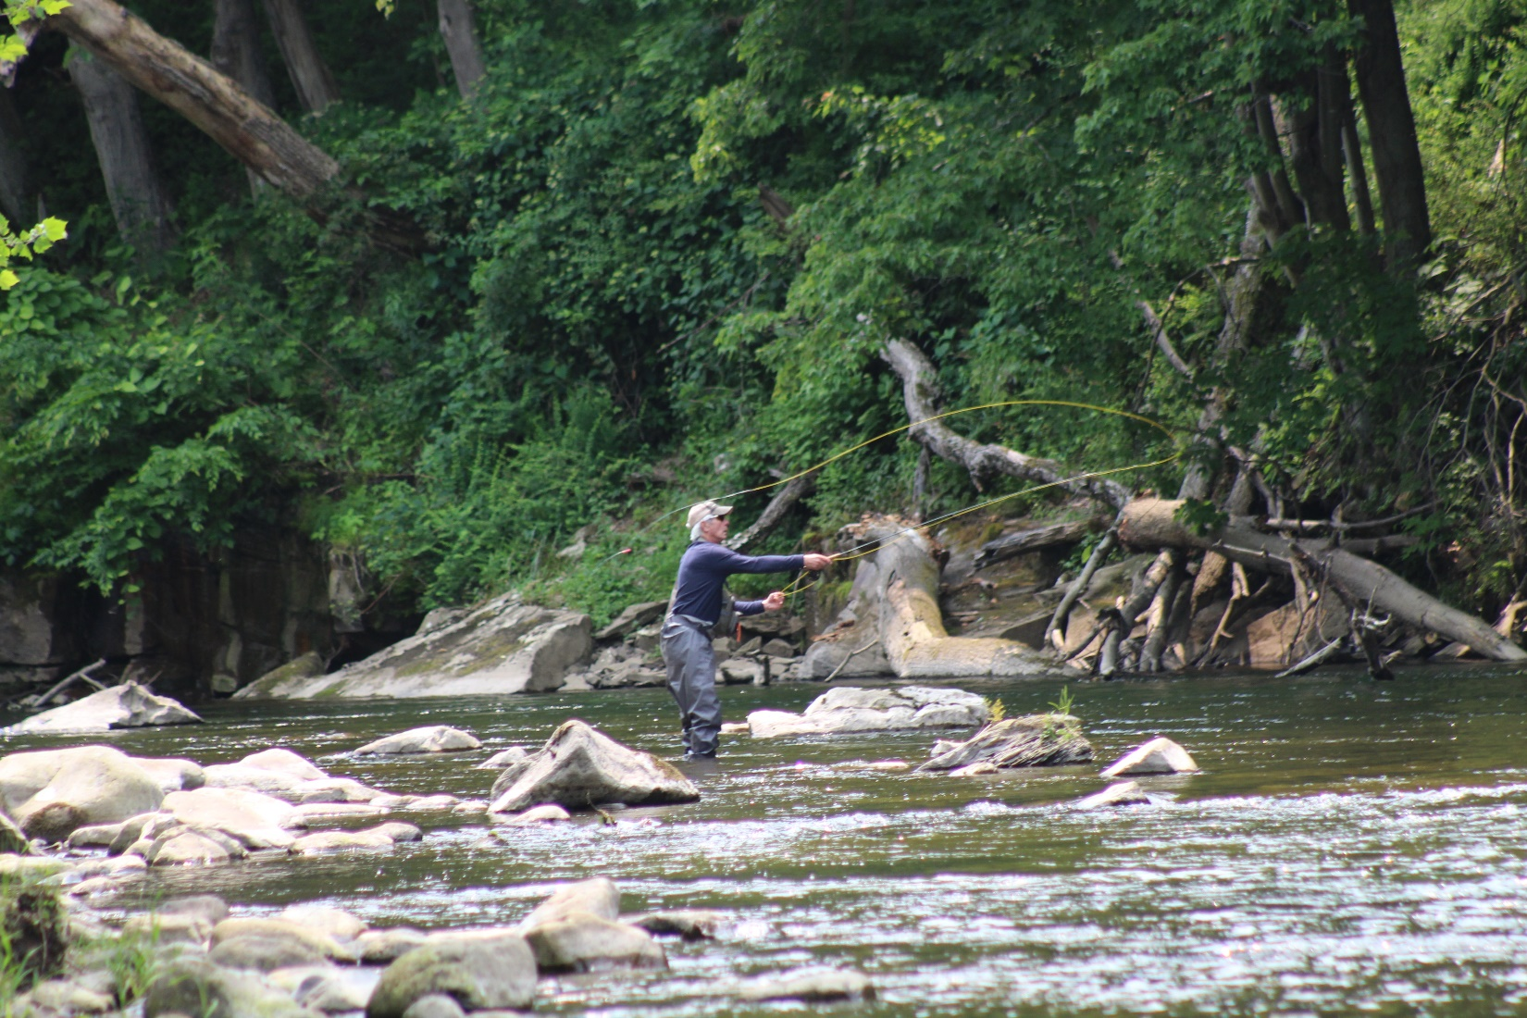
Fishing

The North Branch of the Potomac River is fast becoming one of the best trout streams in West Virginia. Access to the North Branch is via the Barnum Whitewater Area. There is approximately one mile of river frontage along the old CSX railway.
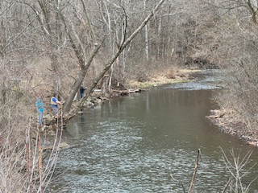
The West Virginia Department of Natural Resources (DNR) stocks lakes and rivers in Mineral County. The schedule is as follows: the lake at Larenim Park in January and March; New Creek (Grant County line downstream 13 miles to Keyser) once in January, twice in February, and once each week from March through May; and North Branch of the Potomac River (from Barnum downstream one mile) once each month from February through May and once during the two weeks after Columbus Day week.

Public Lake and Pond Access Sites
Lake/Pond | Acres | Parking | Boat Access | GPS
 |  |  |  | Latitude | Longitude
Fort Ashby | 12 | Lot | No boats | 39.4857 | -78.7592
Fort Ashby Fishing Pier | 12 | Pull off | Carry-down boat access | 39.4817 | -78.7586
Jennings Randolph Lake | 952 | Lot | Boat access with concrete ramp | 39.4096 | -79.1201
Larenim Lake | 4 | Lot | Carry-down boat access | 39.3675 | -78.8951

River and Stream Access Sites
Site Name | River or Stream | Parking | Boat Access | GPS
 |  |  |  | Latitude | Longitude
Headsville | Patterson Creek | Pull off | Carry-down boat access | 39.3924 | -78.8537
Barnum | North Branch Potomac | Lot | Carry-down boat access | 39.4552 | -78.1022
Keyser | North Branch Potomac | Lot | Carry-down boat access | 39.4443 | -79.9730
Wiley Ford | North Branch Potomac | Lot | Carry-down boat access  District 2 Fishing Guide, wvdnr.org | 39.6105 | -78.7569

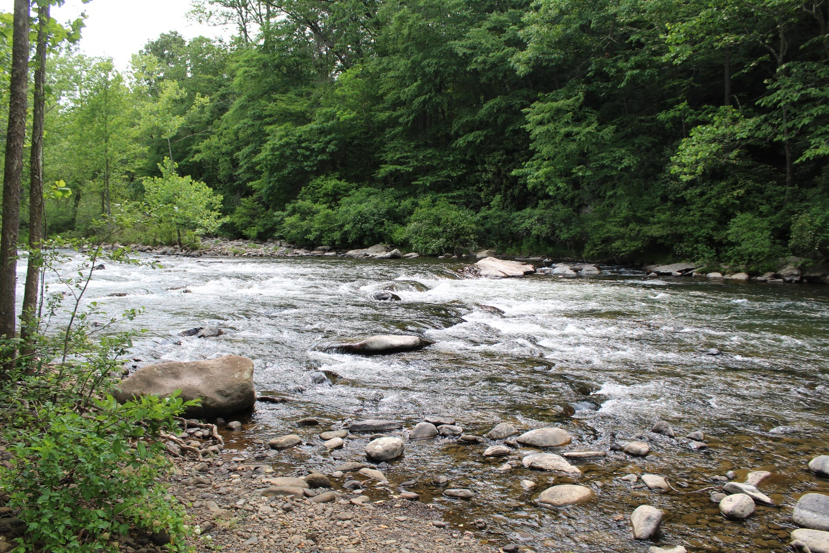
Clyde’s River Guides & Outfitters provides everything you need for your river adventure including lessons, guides, and/or shuttles along the western Potomac River
watershed. There is basic equipment for sale or rent for your time on the river. Clyde’s River Guides & Outfitters is located at 155 Burkhart Road, Ridgeley. Follow them on Facebook/ClydesRiverGuides.
River Adventures

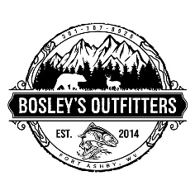
Bosely’s Outfitters is another local retailer specializing in fishing, hunting, and outdoor equipment. If you want to spend some time outdoors, make sure you stop at
Bosely’s Outfitters for your needs from fishing poles to reels to bait. Bosely’s Outfitters is located at 9412 Frankfort Highway, Fort Ashby. Follow them on Facebook/BosleysOutfitters.

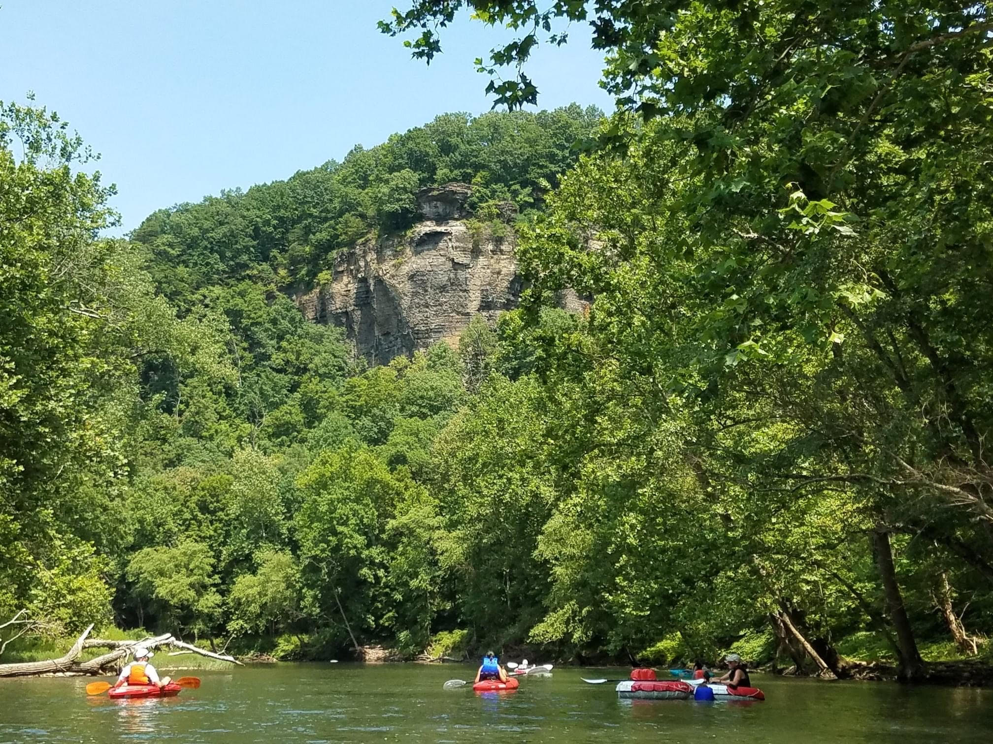

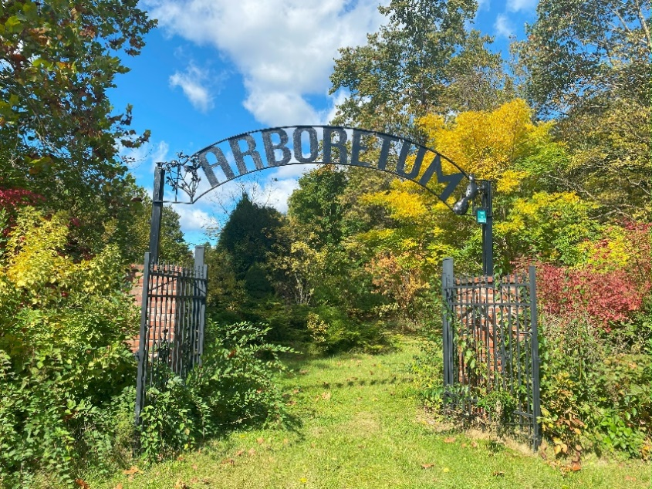
Larenim Park
Larenim Park offers something for everyone. There is water for fishing, acreage for hunting (permit required), trails for hiking (about five miles, total), an arboretum for strolling, benches for enjoying, and fields – soccer and baseball – for playing. The park has 373 acres and is located at 1 Thespian Drive in Burlington.
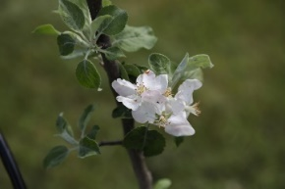
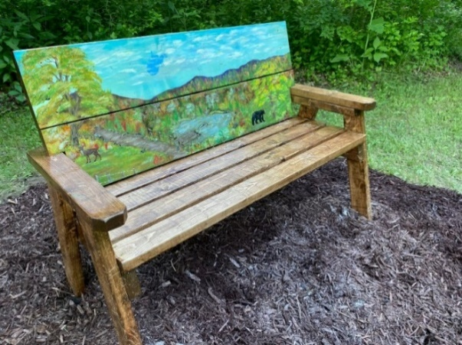

Gold Star Mothers Memorial Orchard
In 2021, 55 apple trees were planted to represent the 55 counties of West Virginia. The American Gold Star Mothers, an organization composed of mothers of fallen members of the military, have been working to establish this living memorial dedicated to the men and women of the U.S. Military who paid the ultimate sacrifice fighting for their country.
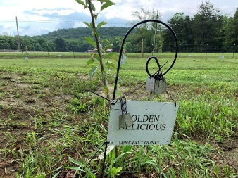
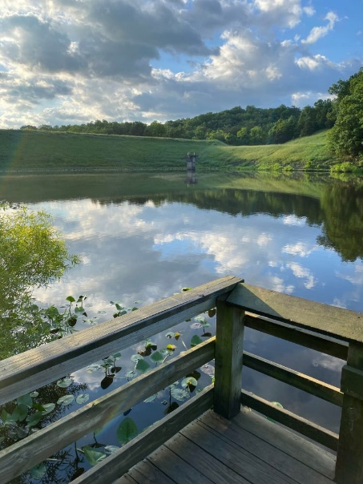
The flood-control lake comprises four acres and is stocked by the WVDNR once in January and once in March. The lake has a parking lot and a pier for fishing. The lake also has carry-down boat access.
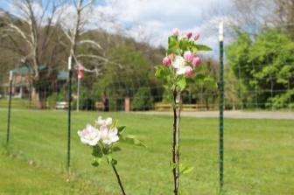
There is also fishing and boat access to Patterson Creek behind the athletic fields.

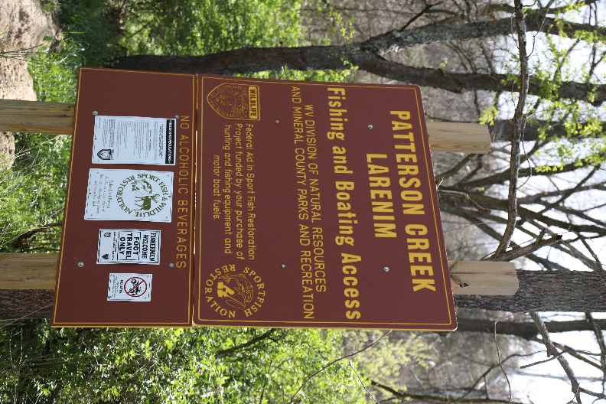
There are three soccer fields and four ballfields (two Little League and two softball) at the park as well as a playground and a couple pavilions.

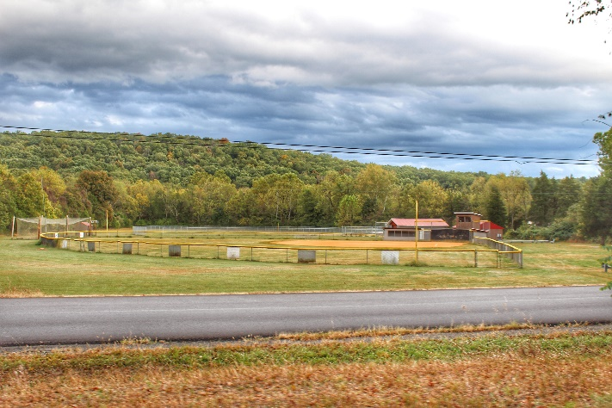
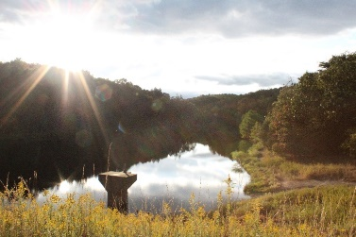

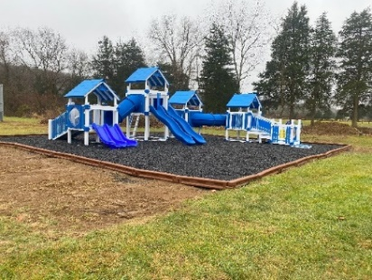
Mineral County Heritage Trail
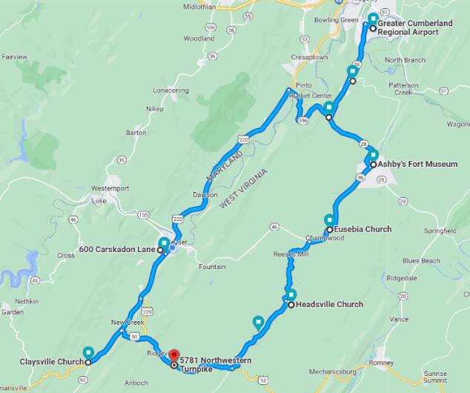
Are you interested in history? Mineral County has played a role in some of the most pivotal times in our nation’s history from the French & Indian War to the Civil War. The area is rich in history with many historical sites available to visit. Some locations are open to the public on a regular schedule throughout the year or can be open for a private tour by calling the Mineral County Welcome Center at (304) 790-7081. It would take more than one day to visit all the heritage sites!
Heritage Trail Map

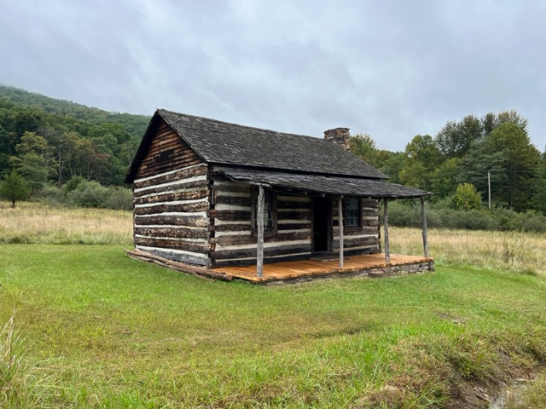
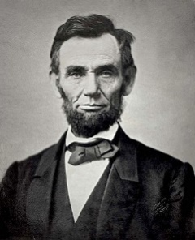
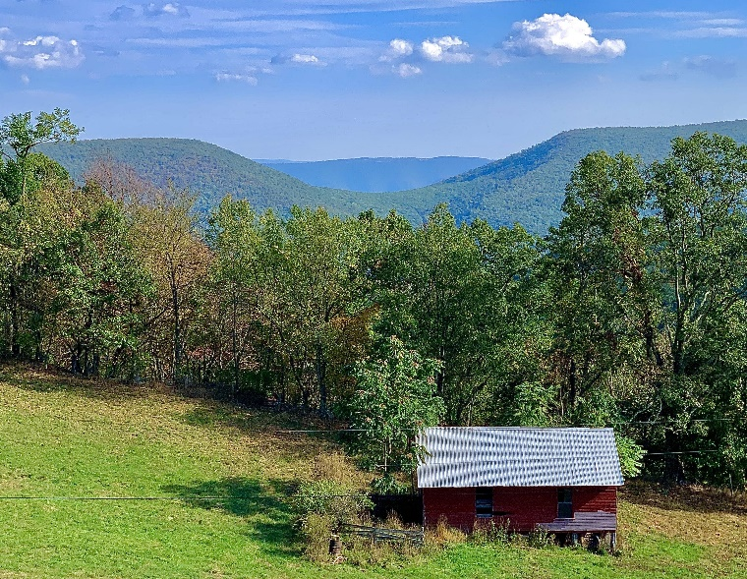
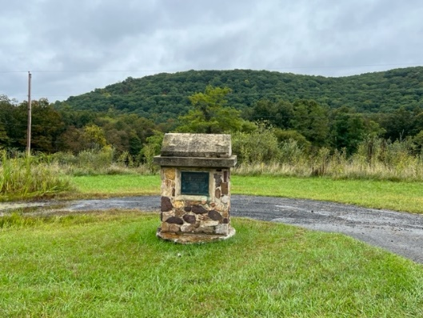
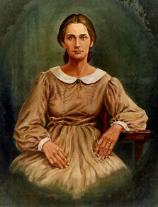
Private tours can be scheduled by calling the Mineral County Convention and Visitors Bureau (CVB) at (304) 790-7081 or via email at MineralCoCVB@gmail.com.
Nancy Hanks Cabin
Nancy Hanks Memorial, Nancy Hanks Drive, New Creek
Nancy Hanks Lincoln, mother of the 16th President of the United States, Abraham Lincoln, was born in present day Mineral County. It is believed that she was born east of Saddle Mountain (below) and lived there until she and her mother were sent to live with family in Kentucky. Lincoln said of his mother, “All that I am, or hope to be, I owe to my angel mother.” The cabin, which dates back to the 1970’s, is a replica of the cabin where Hanks was born. It was previously located on Patterson Creek Road before it was dismantled and moved to its current location, opposite her memorial.
In 1933, the Nancy Hanks Commission established a memorial near the site of her birth and erected a small rock monument with a bronze tablet.
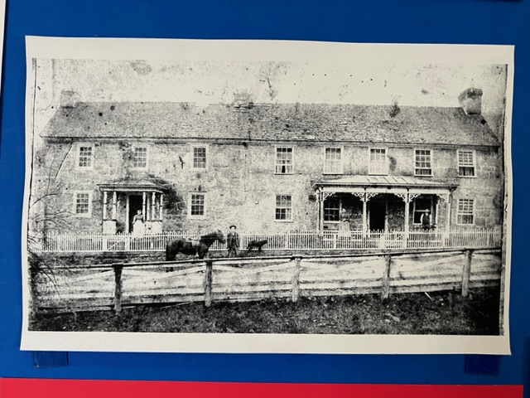
Traveller’s Rest (Stone House)
5772 Northwestern Turnpike, Burlington

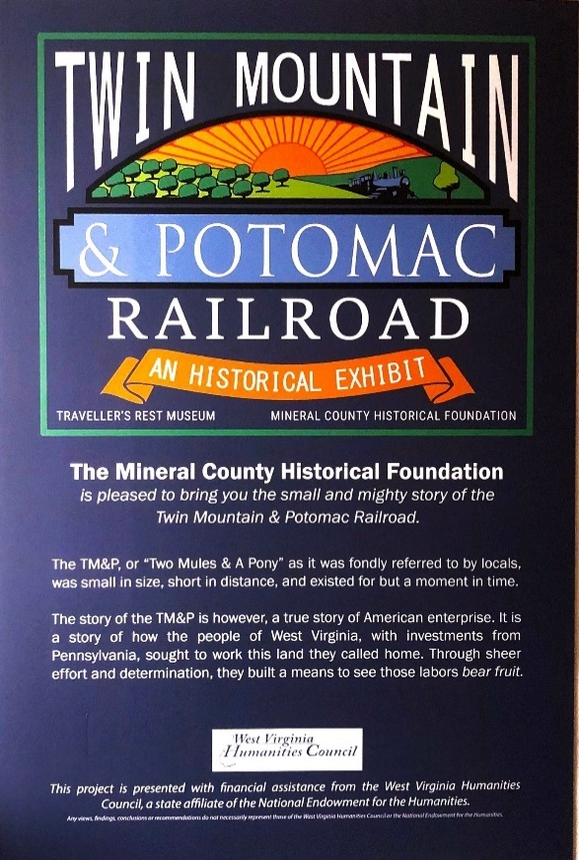
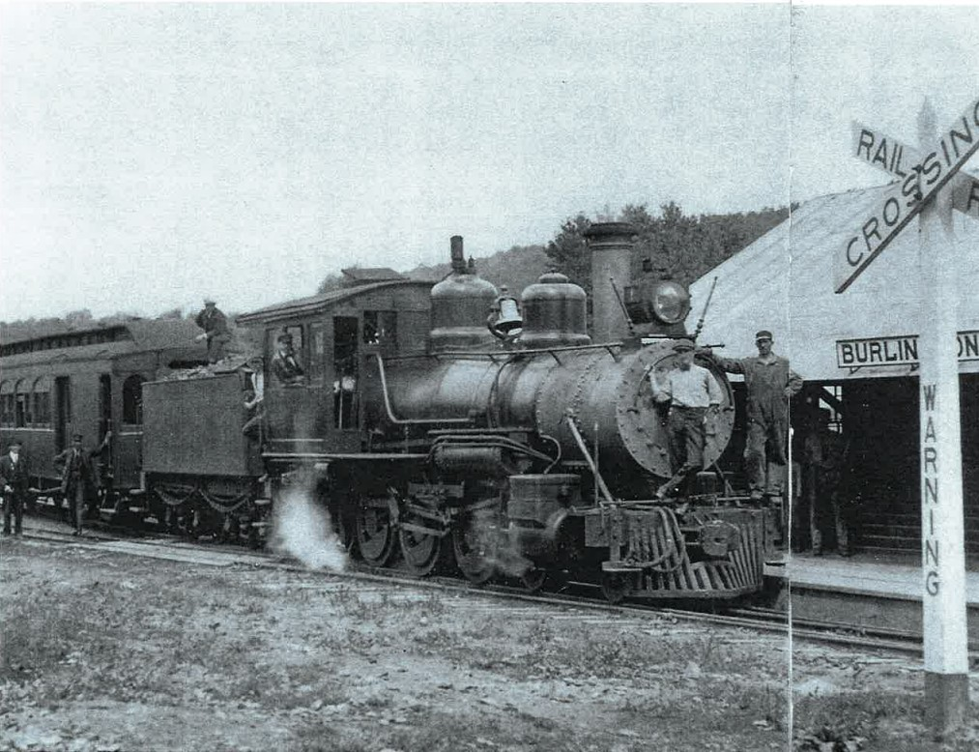
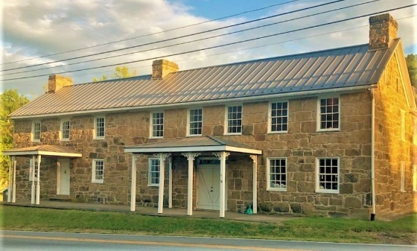
In 1928, the initial section of Traveller’s Rest was built. It was built as a stagecoach stop to service the Northwestern Turnpike. The stone used was hauled by mule-drawn wagons 2 ½-mile journey from Knobley Mountain.
Traveller’s Rest originally sat on 50 acres of land, providing space for herds of livestock to be pastured as they were moved along the Turnpike, which was used as a stagecoach route until 1915.
The Twin Mountain and Potomac (TM&P) Railroad was a 26.6-mile narrow gauge (30” between rails) railroad that ran from Keyser to northern Grant County in West Virginia. It was built to transport peaches and apples to the Baltimore and Ohio (B&O) railhead in Keyser for shipping to the eastern market. Construction began in early 1911, and before the end of the year, the railroad had reached Burlington, West Virginia. The freight and passenger station built in Burlington is still standing. The line was completed to northern Grant County in 1912. The TM&P Railroad was a good idea when it was built, but innovation made it obsolete in eight short years. The line never showed a profit. It was shut down in 1919 with the last run being in February of that year.
In 1827, Virginia commissioned the Northwestern Turnpike to be constructed connecting Winchester, Virginia and Parkersburg, Virginia (now West Virginia) with toll gates located every 20 miles.
Carskadon Mansion
600 Carskadon Road, Keyser
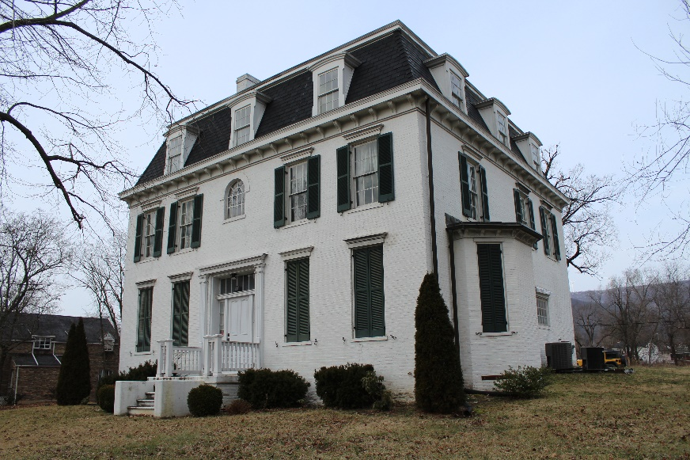
The Carskadon Mansion was listed on the National Register of Historic Places in 2002.

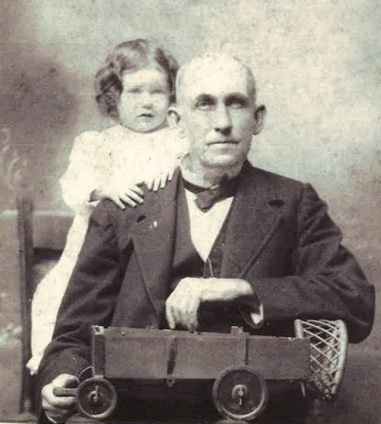

Thomas R. Carskadon, with his granddaughter, holding a prototype of a dumping wagon.

This historic home, constructed circa 1866, is located on Radical Hill in Keyser, West Virginia. When the mansion was built, it was a grand structure. This three-story, eight-bedroom home features iconic architecture unique to the era in which it was built, including wide center halls, grand fire places in almost every room, and a long staircase. It stood on approximately 600 acres of land. It is the former residence of Thomas R. Carskadon, an influential Mineral County farmer and political leader. Carskadon holds many patents and wrote articles that gained great attention in agricultural circles throughout the United States. Carskadon built the first silo in the eastern United States.

Mineral County Historical Society Museum
253 Carskadon Lane, Keyser

The museum features local items dating back to the early 1800’s. Some of the most treasured items are:
- Complete uniform and personal military pack of Oliver Frederick Liller, who served in WWI.
- The Funeral Corner which includes a funeral receiving basket, funeral home memorabilia, portable embalming table and a typical mourning dress.
- Early 1940’s Boy Scout uniform, and other items.
- A display of Leslie Thrasher who was born in Piedmont in 1889 and is known for his illustrations that rivaled Norman Rockwell’s.

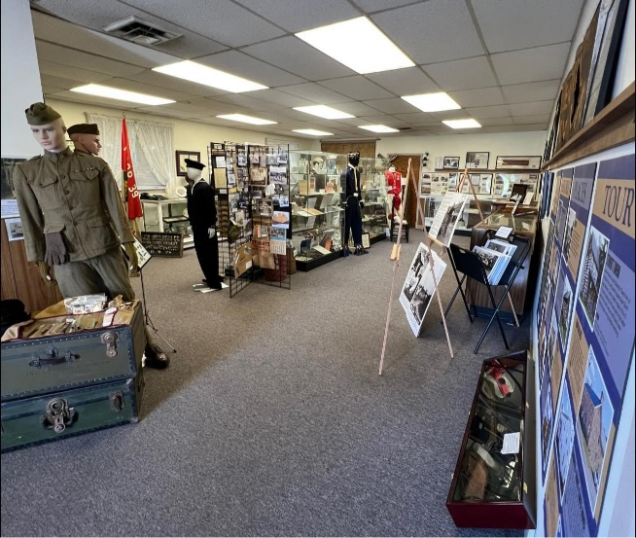
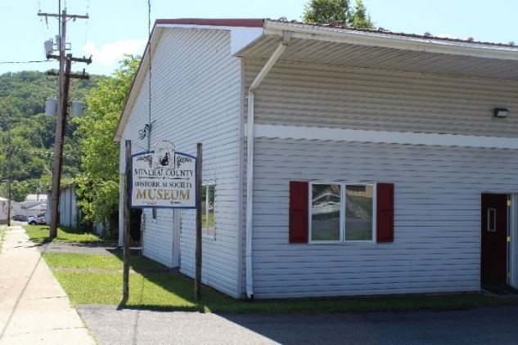


Stewart’s Tavern
44 Knobley Road, Ridgeley

John Stewart’s Tavern is one of the oldest buildings in Mineral County. The historic log cabin has been an inn, a stagecoach stop, a tavern, a personal residence – and is now a museum. Mr. Stewart operated the tavern until his death in 1835. He was never the tavern proprietor. This 2 ½-story building was built in the latter part of the 18th century (between 1790 and 1797) with hand-hewn chestnut logs with having steeple notching. It was moved approximately 60 feet from its original location.
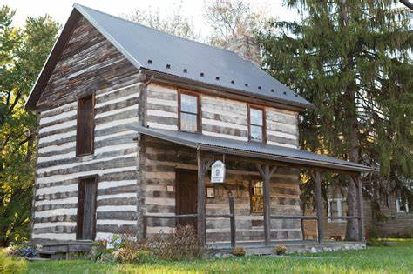

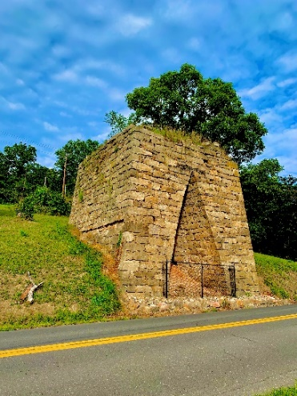
The Old Furnace
189 Old Furnace Road, Short Gap

In the early 1840’s, John Gamber of Pennsylvania invested $16,000 in 200 acres of land. He had visions of making a fortune producing iron. The stone furnace, a blast furnace, included a large steam boiler, a steam engine, and an on-site well, located just to the left of the furnace. The fuel, limestone, and iron ore were fed into the top of the furnace and the resulting iron was removed from the bottom at the draw pit. Gamber was not as successful as he had hoped; the iron furnace and 200 acres were auctioned off in 1850. It remains one of the most well-constructed furnaces of its kind and the only iron furnace in Mineral County.

The preservation, restoration, and maintenance of Stewart’s Tavern and The Old Furnace are under the auspices of the Frankfort District Historical Society.

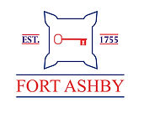
Ashby’s Fort Museum
227 Dan’s Run Road, Fort Ashby
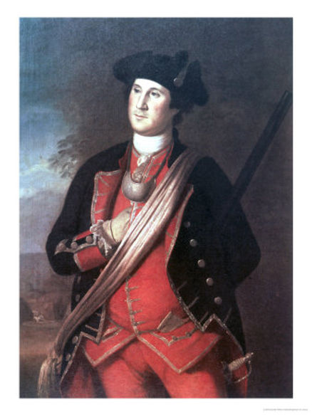
(March through October, Hours: Friday/Saturday 10am-4pm; Sunday 12-4pm)
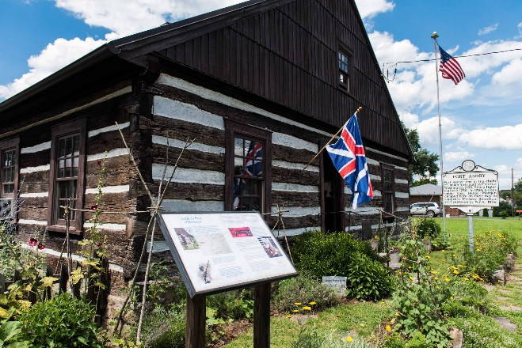
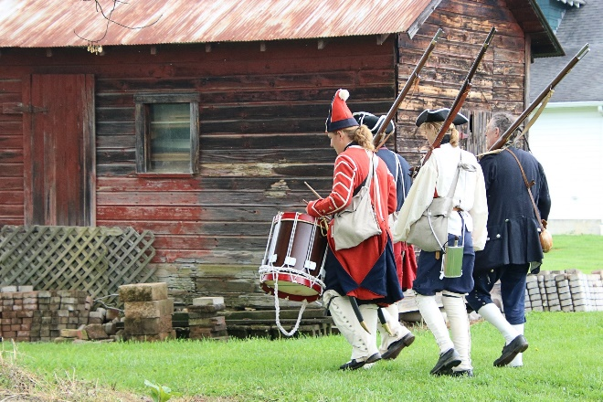

The French and Indian war was a conflict between Britain and France, fought in North America over disputed territory. Indian nations aligned themselves with whichever side they felt would be more advantageous to their interests. Twenty-two-year-old George Washington was sent on a mission to support William Trent, who was building a Fort at the site of modern-day Pittsburgh. While Washington was on his way, the French had driven Trent away from the Fort and continued building it for themselves, naming it Fort Duquesne. As Washington neared the Fort, he joined up with a friendly Indian party, then attacked a French scouting party commanded by Joseph Coulon de Jumonville on May 28, 1754. Jumonville was killed during the battle, known as the battle of Jumonville Glen, thus starting the war.

Washington retreated, knowing he would be followed by the French, and built Fort Necessity near present-day Uniontown, Pennsylvania. The Fort was built hastily as a circular Fort. When the French finally arrived on July 3rd, commanded by none other than Jumonville's brother, they attacked and quickly forced Washington to surrender the indefensible Fort. This is the only time in Washington's life that he surrendered. Jumonville allowed Washington and his men to leave under arms after getting him to sign a document written in French that essentially was a confession to starting the war.

The following year, General Edward Braddock left England with a force of 1500 British regulars bound for America. George Washington was made an assistant to Braddock and they made Fort Cumberland, the starting point for Braddock's expedition to retake Fort Duquesne. Nearing Fort Duquesne in June of 1755, the British army was ambushed by French and Indian forces who decimated them, killing or wounding a thousand, including Braddock who died four days later. Washington led the survivors back to Virginia.

With no British troops left to protect Virginia, Indian raids became fierce, terrorizing frontier homesteads, burning homes, crops, and buildings, and scalping men and kidnapping women and children. Governor Dinwiddie made Washington a Colonel and gave him command of the Virginia Regiment with additional men authorized by the colony. Two Companies of Rangers were authorized to protect Hampshire County, which included present day Mineral County. Captain William Cocke had 1st Company, and Captain John Ashby was given 2nd Company. Both Captains set about recruiting men for their commands, and by early September, Ashby had thirty-two Rangers.

Washington ordered the construction of the Fort located in present day Fort Ashby, West Virginia, in late October, 1755. Capt. Ashby's company finished the construction quickly, as the danger of attack from the Indians was great. Most, if not all, civilians around Fort Ashby had already been killed or driven off by the time the fort was constructed.

Once the Fort was constructed, Ashby and his 32 Rangers patrolled the area between Fort Cumberland to the North, and Fort Cocke, ten miles to the south on Pattersons Creek. They also escorted military parties and supply wagons along the road. Fort Ashby
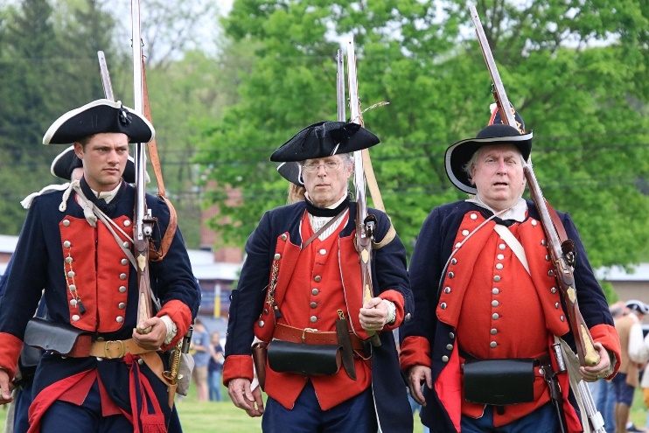
continued to be manned by Virginia Regiment soldiers until May of 1757.

The tide of the war changed completely when a British force of 6000 soldiers, led by British General John Forbes, including those from Virginia's frontier Forts, as well as other colonies, formed in 1758 to take Fort Duquesne. The French won the first battle against an advance party of the British soldiers but abandoned the Fort when they realized they had no chance against an army 10 times larger than their own. The Indians perceived the French withdrawal as a major weakness, and their attacks on the English colonists were dramatically reduced.

With the French out of the picture, and the Indian attacks nearly stopped, Ashby's Fort was never manned again.
Other Historical Sites
Claysville Church
Intersection of Route 50 & Route 93
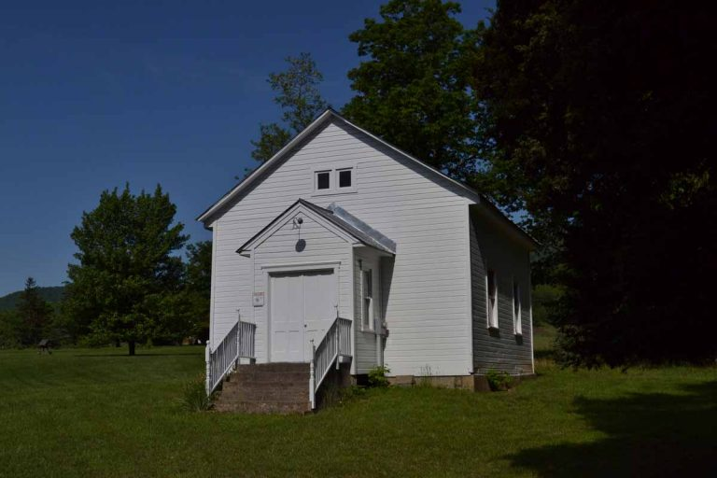

In 1849, the citizens of Claysville, West Virginia, were determined to establish a church. The ground was donated jointly by Reuben Davis and John Liller at a place where their properties joined. Daniel Hendrickson organized the first congregation of more than fifty members, and a year later, the Claysville Church was built. It is the oldest church building in Mineral County. Even though it was extensively renovated around 1926, it has remained basically the same.

The Claysville Church has significant historic ties to the Civil War. During the war it served both the Union and Confederate Soldiers. Some troops would serve as guards outside while the rest of the soldiers worshipped.

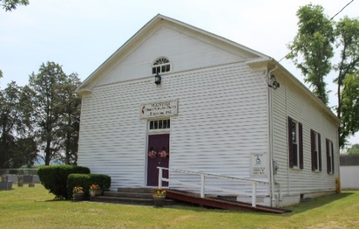
Headsville Church/Headsville School
9 Ranch O Villa Glen Road, Burlington

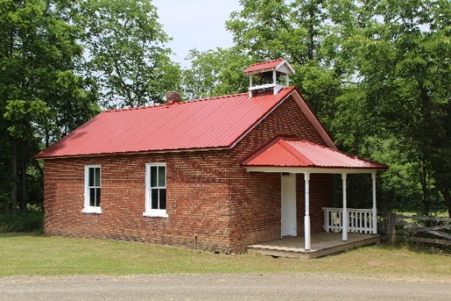
The Headsville Church Cemetery is the final resting place of Thomas R. Carskadon, of the Carskadon Mansion, and many of his relatives.
Tucked away in a corner of the Headsville Church property is the Headsville School. This school is one of the oldest school buildings of which there is a definite record. The one-acre lot was from James Carskadon by deed dated June 25, 1871. The building served as a school until it merged with Burlington in 1934.

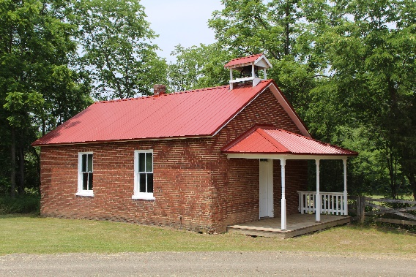

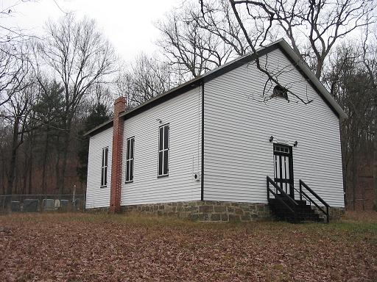

Eusebia Church
Ed Oats Road near Sycamore Lane,
near Fort Ashby

Eusebia Presbyterian Church is one of the two oldest worshipping congregations in Mineral County. The original building, built in 1819, burned. The current structure was patterned after the original church when it was constructed in 1891 at the cost of $900. An active congregation worshipped in the one-room log structure, serving the local community from 1819 to 1947. It also served as a barracks and hospital for both sides during the Civil War.
The church cemetery is the final resting place of the Reverend Malcolm Woodworth, Captain George Sheetz, and artist/illustrator J. Frank Holm.

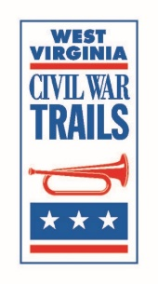
Fort Fuller Interpretive Sign: Part of the West Virginia Civil War Trail, it is located at the Mary F. Shipper library, on the Potomac State College campus. Learn about Keyser’s Fort Fuller and the role it played during the Civil War. The library is located at 101 Fort Avenue, Keyser.

Local Historical Organizations
Frankfort District Historical Society Facebook: Frankfort Historical Society
Friends of Ashby’s Fort Facebook: Friends of Ashby’s Fort
Website: FortAshby.org
Mineral County Genealogical Society Facebook: Mineral County Genealogy
Mineral County Historical Foundation Facebook: Stone House / Travelers Rest WV
Mineral County Historical Society Facebook: Mineral County Historical Society;
Website: MCWVHS.org

Greater Cumberland Regional Airport/Cohongaronta Gallery (museum)
165 Terminal Loop, Wiley Ford
(open 7 days a week from 8am to 8pm)
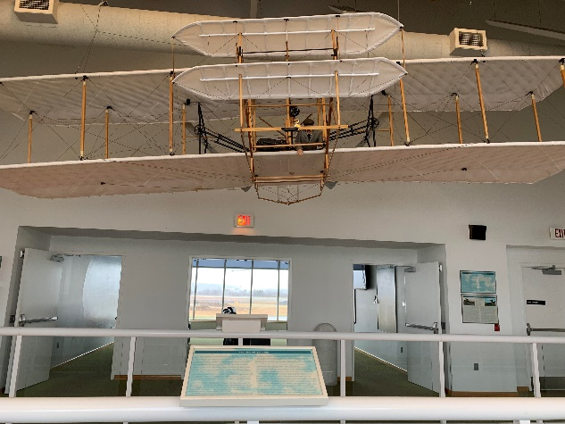
The Cohongaronta (Shawnee name for the Potomac River) Gallery is located on the second floor of the terminal. The gallery contains a scaled (40%) replica of the Wright Brothers’ 1903 first powered flight aircraft that set the stage for aerial transportation. A 70-foot-long timeline highlighting pertinent dates and events for the Potomac Highlands region is also on display in the gallery. Stop by and learn about the history of Mineral County regarding aviation, automation, and much more.
E.A.A. Chapter 426
Greater Cumberland Regional Airport
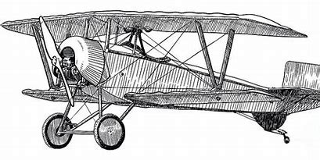
Fly-In/Drive-In Breakfast

April 28, May 26, June 30, July 28, August 25, September 29 (Wings & Wheels)
8:00am until 12:00pm
All you can eat on the premises: hotcakes, scrambled eggs, sausage, sausage gravy, fried potatoes, fruit cocktail, coffee and orange juice.
$12 adults and $6 under age 12
Free ‘Young Eagle’ airplane rides for ages 8 to 17, weather permitting and pilots available.
www.Facebook.com/EAAChapter426

The local chapter of the Experimental Aircraft Association (EAA, Chapter 426) hosts a breakfast at the airport to raise money to send a young teen to Oshkosh, Wisconsin to attend the EAA Air Academy. A once in a lifetime experience! See the flyer (left) for more information.
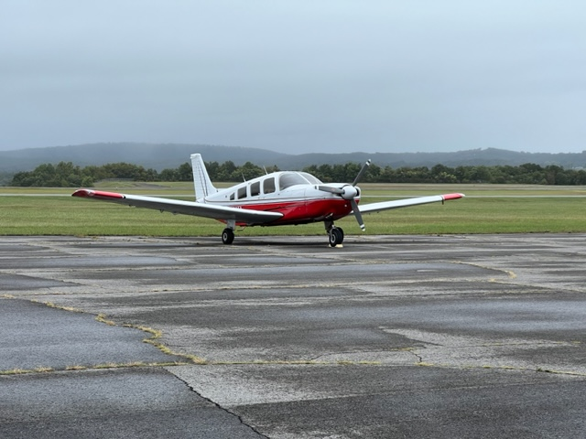

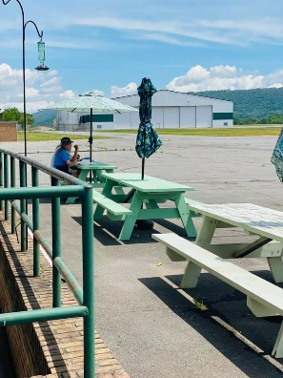

Hummingbird Café
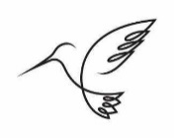
Also located at the airport is the Hummingbird Café. This unique, restaurant, which offers indoor as well as outdoor seating, appeals to both food and airplane lovers. Sit and enjoy your meal near a runway, while watching planes come and go!

Local Farms

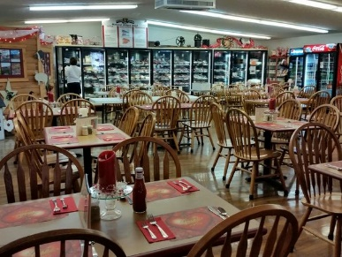
There are several farms in Mineral County that provide different services and products throughout the year.
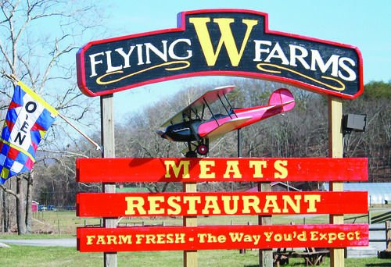
Flying W Farms has a restaurant and store (2939 Northwestern Turnpike, Burlington) that features local food from their farm – on the menu and for purchase. The menu is made up of carefully prepared
meats and crisp vegetables with hand-dipped ice cream and freshly baked pies for dessert. The store has a variety of handmade crafts as well as jams, jellies, honey, and maple products.



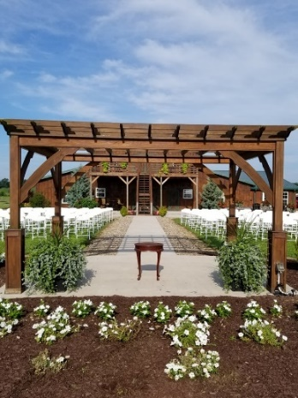
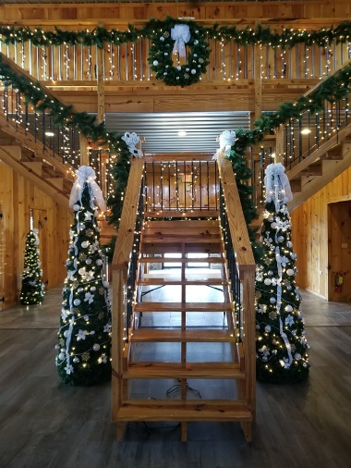
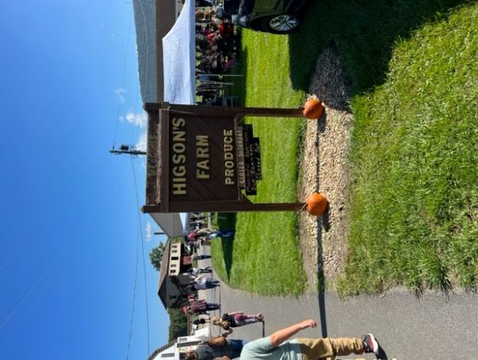
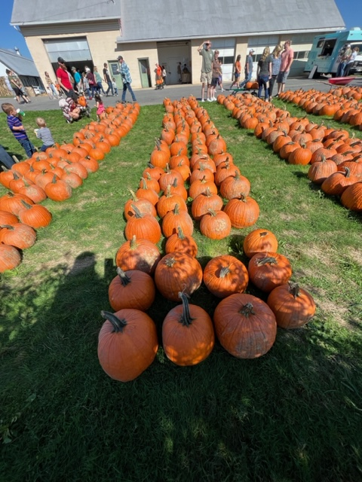
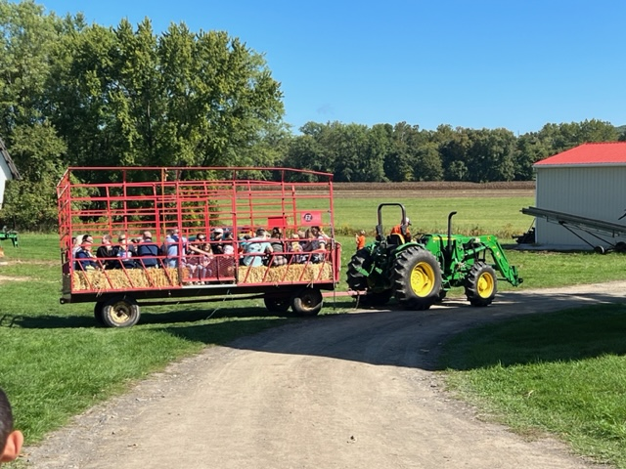
Brookedale Farm (369 Georges Run Road, near Fort Ashby) is known for their beautiful event venue. They also have a greenhouse and a corn maze on-site and host many local events – indoors and outdoors. The Stadell at Brookedale is available for weddings, showers, dinners, parties, and so much more! The Greenhouse is open March through June, Monday through Saturday, as well as some Sundays, providing great selections for your flower and vegetable needs. In fall, the Brookedale Family Corn Maze is a popular community and family event.
“We are not fast food nor fan food; we are farm fresh, slow good, enjoy and taste the difference.”
Higson’s Farm (2276 E Maple St, Wiley Ford) offers an on-site produce market along with other fresh edible products. The farm also hosts a Fall Festival with hayrides, pony rides, crafters, food, and lots of pumpkins and other farm fall décor.
Golf Courses
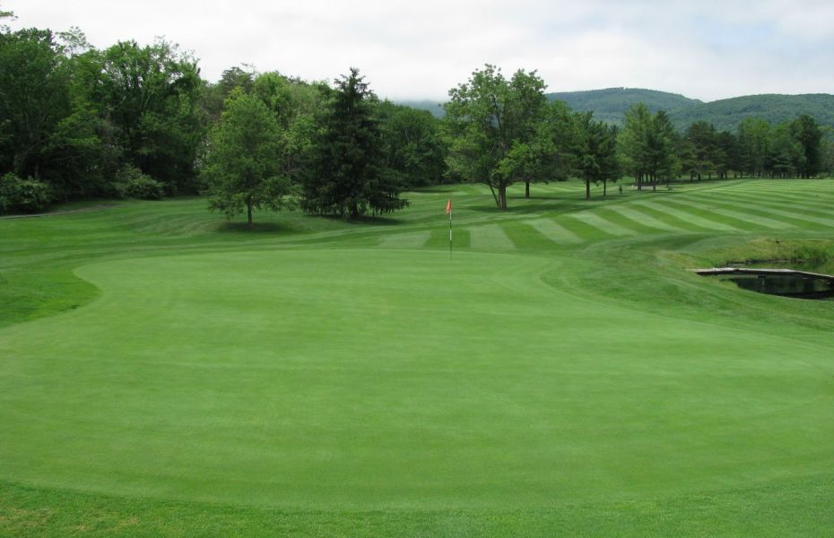

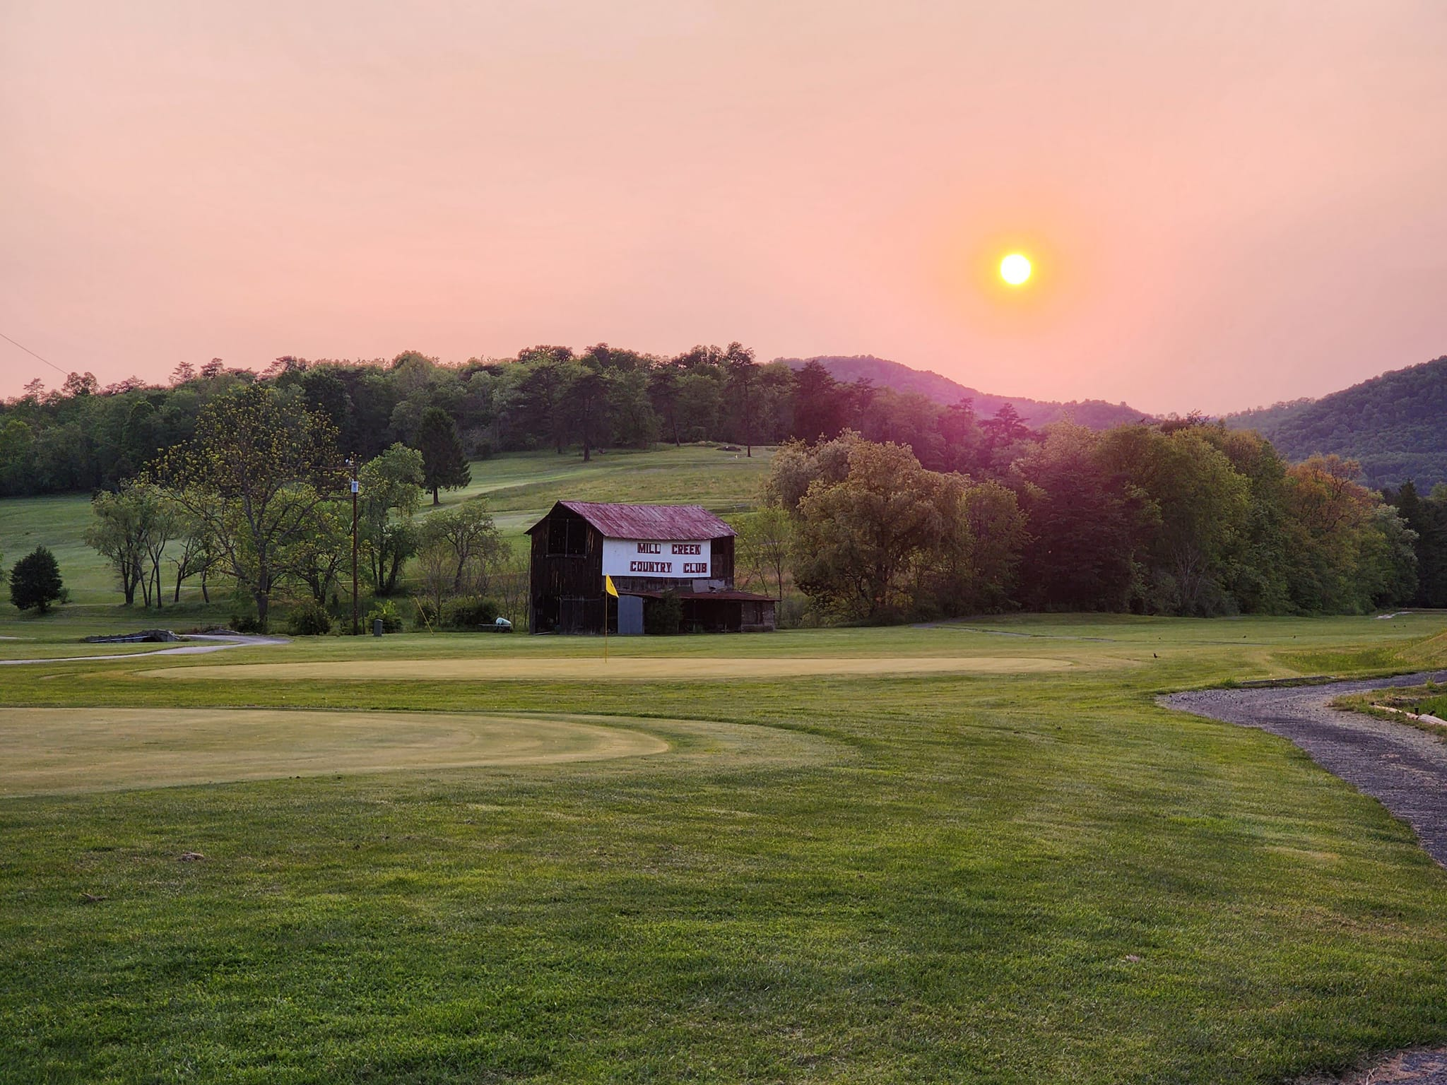
Grab your clubs and tee off at one, or both,
of these scenic golf courses!
Mill Creek Country Club, located on Route 50 in Burlington, offers a delightful golfing experience. This 9-hole regulation length course caters to both beginners and seasoned golfers. Designed by James Spencer, it opened its greens in 1967. Whether you are practicing your swing or enjoying a leisurely round, Mill Creek Country Club provides a great setting.
Polish Pines Country Club offers terrific views and challenging play for golfers at every skill level. Well-groomed fairways and greens make this 9-hole course a terrific choice for regular rounds of golf or a new destination w. Polish Pines Country Club is located at 158 Polish Pines Loop, Keyser.
Polish Pines Country Club
Mill Creek Country Club
Unique Stops

Mineral County is full of tasty restaurants, unique shopping, and specialty businesses. Here are a few local stops along your way…
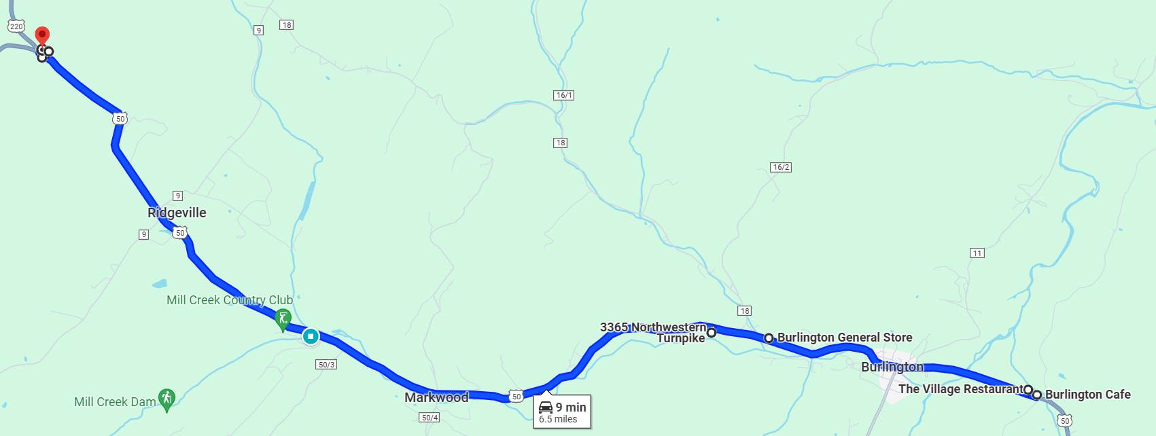
Northwestern Turnpike

Northwestern Turnpike from Burlington to New Creek features several places to have a meal, get a snack, and/or shop! The Burlington Café (1520) and the Village Restaurant (1588) are neighboring restaurants that complement each other from hours to menu items, and both have a daily special. Flying W Farms (2939) is a restaurant with both indoor and outdoor seating that also features fresh meats, produce, and desserts, as well as a few crafts for sale. The Burlington General Store (3074) is a small country store with gas/diesel/propane, groceries, pizza & wings, hardware, automotive, and just about anything else you may need. Continue to Criterion West/Garden Shack (3365), a unique collection of gifts and items to pamper yourself, your house, and your garden. Traveller’s Rest/Stone House (5772) has an indoor flea market (sometimes with a hot breakfast and lunch) and the new Twin Mountain & Potomac (TM&P) Railroad display. Certain weekends (Route 50 Yard Sale in May and Apple Harvest Festival in October) they host outdoor vendors, as well. Check Facebook (Stone House / Travelers Rest WV) for their schedule. Close to the turn-off to head to Keyser is a cluster of places to stop. The Knobley Farm Sports Shop (7789) is where you can get everything you need for your outdoor adventure. Across the street is Knobley Mountain Auction (8018) which has on-line auctions
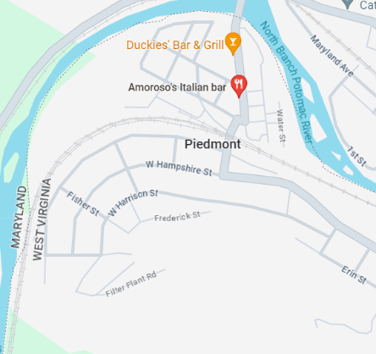
(KnobleyMtn.Hibid.com) and a physical store featuring household décor, including furniture (new and used), antiques, and country décor.
Piedmont

As its name suggests, Piedmont is located at the base of a mountain, in this instance the foot of the Allegheny Front, the eastern edge of the Allegheny Mountains, on the south (West Virginia) side of the North Branch of the Potomac River. It is the home of Duckies’ Bar & Grill (100 Ashfield Street), a local favorite for shrimp and wings. Amoroso’s Italian Bar (32 2nd Street), serving homemade Italian foods, subs, pizza, and desserts, is also located in Piedmont.
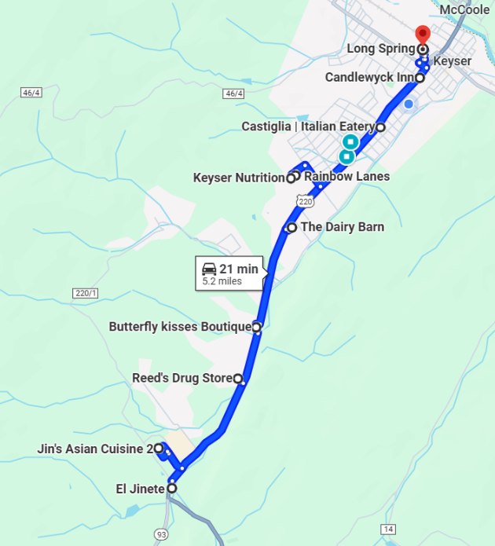
Route 220, starting at the intersection of New Creek Highway and Cut-Off Road, continues to the border of West Virginia and Maryland with an abundance of eating and shopping opportunities. El Jinete (2505 New Creek Highway) is an authentic Mexican restaurant. Heaven Sent Creations (2444 New Creek Highway) is a Christian-based gift shop that offers heartfelt expressions in every gift. Jin’s Asian Cuisine 2 (196 N Tornado Way, Suite 11) is a Chinese, Thai & Japanese restaurant. Double B’s Bar & Grill (1680 New Creek Highway) serves breakfast outside of typical breakfast hours most days, and offers a separate bar area as well as local artisan products. Reed’s Drug Store (41 Pin Oak Lane) provides pharmaceutical needs as well as a gift store featuring Vera Bradley and Gardner’s Candies. Butterfly Kisses Boutique (195 Polish Pines Loop, Suite 3) has unique clothing and accessories for women,
Route 220

men, and children. Dairy Barn (397 New Creek Highway) ice cream shop offers a flavor of the day and a few food menu items. Keyser Nutrition (1585 Cornell Street) offers nutritious shakes, energizing teas, and some local products like t-shirts and large drink cozies. Rainbow Lanes (1575 Cornell Street) is a local bowling alley. Med-A-Save Pharmacy (818 S Mineral Street) is another drug store with a gift shop, featuring Swan Creek Candles and items (custom wood items/country décor) from Lillers Woodshed. Haddy’s (123 Stony Run Road) is another local restaurant. J&S Pawn and Guns (438 S Mineral Street) has nearly everything – tools, coins, gold, firearms (new and used), hunting supplies, collectibles, and much, much more. Castiglia’s Italian Eatery (401 S Mineral Street) is well known in the area for their delicious Italian dishes (carry-out only). Blessed Treasures (233 S Mineral Street/Calvary United Methodist Church) is a thrifting experience where you can also have lunch. It is open on the first Saturday of the month and Tuesdays from 10am - 2pm. The Candlewyck Inn (65 S Mineral Street) is known for great food and great friends featuring brunch on Sunday and several daily food specials. Long Spring (220 Keyser Mall) is a cozy Chinese restaurant featuring an all-you-can-eat buffet. Orioles Club (40 Keyser Mall) is a welcoming establishment offering good food and a friendly atmosphere.
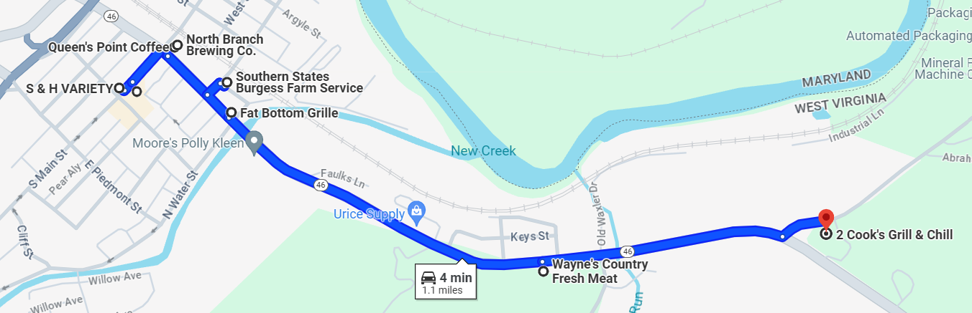
Downtown Keyser

Main Street has the feel of an old town with one-way traffic, parking meters, and old store names still marking the buildings and sidewalks. There are two thrift stores on Main Street offering new, used, and some handmade items: Five Star Pawn (60 N Main Street) and S&H Variety (79 N Main Street). There are two restaurants, both with that small-town vibe: The Royal Restaurant (88 N Main Street) featuring diner-type foods since 1904 and Hometown - The Last Stand (96 N Main Street) highlighting hot dogs but offering something for everyone. Main Street soon intersects with Armstrong Street that has a variety of experiences. Solar Mountain Records (21 Armstrong Street) has over thirty thousand records (45s and LPs) plus CDs and cassettes at this brick-and-mortar store. M&S Desserts and Bakery (133 N Main Street) specializes in all varieties of pastries and cakes. Queens Point Coffee Shop and North Branch Brewing (101 Armstrong Street) share a building with one providing multiple coffee drinks, breakfast/lunch menu items, and bakery items; and the other a small batch brewery featuring other local brewers on-tap and food items with nightly specials and events such as Trivia Night and live entertainment. Friends of Felines and Ferals (113 Armstrong Street) draws your attention with adorable cats and kittens in the window of this feline rescue. Fat Bottom Grille (191 Armstrong Street) cooks up big, juicy burgers, steaks, and street tacos bringing new flavors as well as some old favorites to the area. Wayne’s Country Fresh Meats (670 Armstrong Street) is a butcher shop, grocery store, featuring a substantial hot bar for lunch as well as pre-packaged fresh food items to go. Country Roads Pub (777 Armstrong Street) is a recently opened, veteran-owned restaurant already receiving praise on social media. 2 Cook’s Grill & Chill (Fort Ashby Road/Route 46 & Waxler Road intersection) is a permanent food truck with a variety of grilled sandwiches, sides, and more.
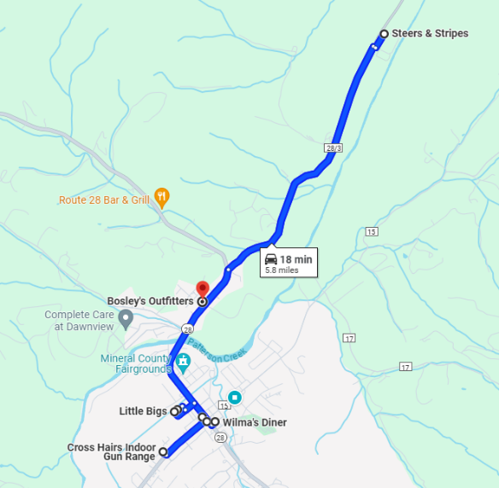
Cross Hairs Indoor Shooting Range (322 Fort Ashby Road) is the only indoor live-fire shooting range in the area that offers six 75-foot lanes and two 25-foot lanes. The Corner Bistro & Vintage Market (10248 Frankfort Highway) is a full-service restaurant with a great atmosphere and a vintage shopping experience. Wilma’s Diner (10261 Frankfort Highway) is a homestyle restaurant with heart. Evans Dairy Dip (10257 Frankfort Highway) is an ice cream shop open during the warmer months. Hummingbird Feeder (10208 Frankfort Highway) opens early for breakfast and is known for their delicious desserts. Little Bigs (126 Presidents Street) serves pasta, wings, subs, and pizza including Chicago-style to mention a few. Wayne’s Country Fresh Meats #2 (102 Presidents Street) is a butcher shop, grocery store, including a hot bar and freshly prepared foods for on-the-go. Mind, Body & Beauty
Fort Ashby
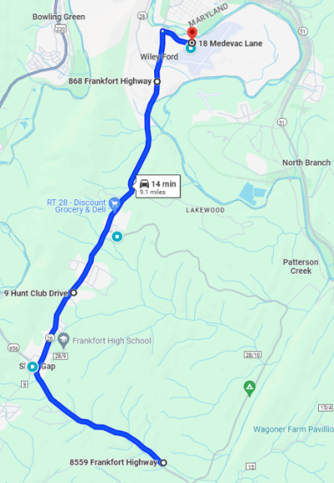
(24 Presidents Street) is a full-service salon offering aesthetics, hair services, lash extensions, nails, massages, and a small boutique. Steers & Stripes Saloon (1714 Patterson Creek Village Pike) is a steakhouse and saloon with great food, live music, and various events. Stop by Bosley’s Outfitters (10538 Frankfort Highway) for your outdoor, hunting and/or fishing needs.

Route 28 Bar & Grill (8559 Frankfort Highway) is the spot where locals gather to enjoy an array of homemade specialties to tantalize your taste buds. Shep’s Pizza (9 Hunt Club Drive) doesn’t just serve pizza; there are wings, subs, salads, and other options on the menu. Linda’s Old Furnace Restaurant (3429 Frankfort Highway) is located steps away from the Old Iron Furnace and serves breakfast all day as well as a daily special. Station Bar & Grill (868 Frankfort Highway) is a local restaurant. Hummingbird Café (18 Medevac Lane) is a family-owned business known for their original location at the airport and their decadent desserts.
When you support a small business,
you are supporting a dream.
Route 28

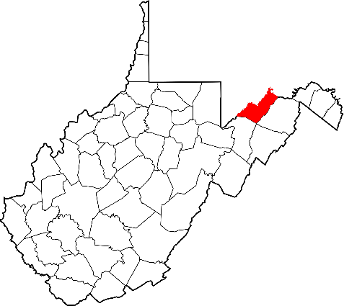
Go Visit

Mineral County, West Virginia

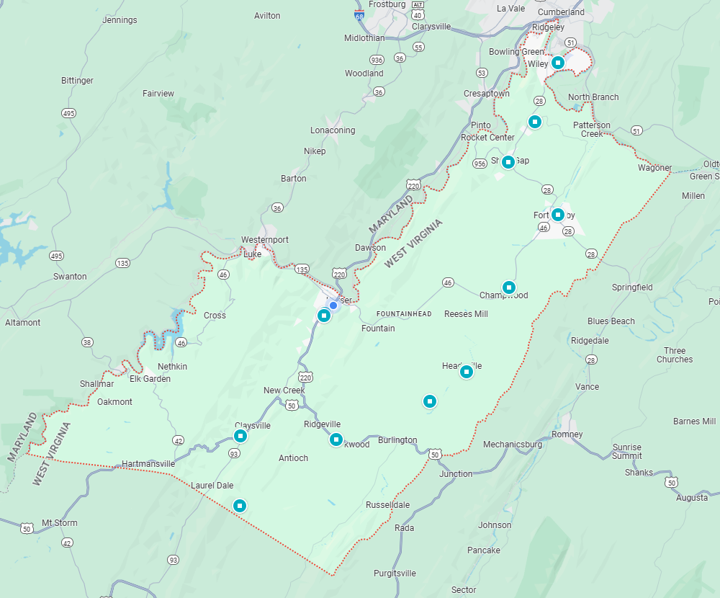
Mineral County Convention and Visitors Bureau (CVB)
Welcome Center
167 S Mineral Street
Keyser, WV 26726
(304) 790-7081
MineralCoCVB@gmail.com
GoVisitMineralWV.com
Facebook/MineralCountyTourism
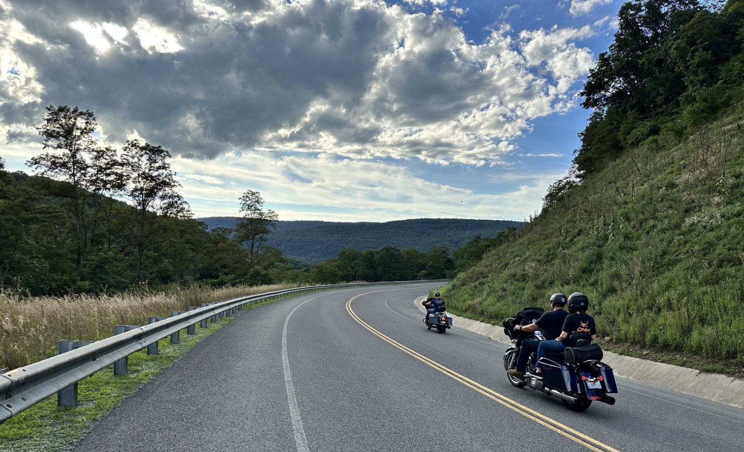
E

Go to a place few have discovered.
Enjoy the beauty in peace.

